English exam preparation
In this reader you will find helpful information for writing, reading and speaking
Skills syllabus 2023-2024
VWO

E-PORTFOLIO 6
Your E-portfolio 7
Scoring 8
WRITING PRACTICE 9
Rules for formal emails 10
Useful phrases in formal emails 13
Scoring your email 15
In General 16
How do you ask or say 17
Frequently used phrases/sentences 18
Common mistakes to avoid 19
Practice makes perfect 23
Practice email writing 26
Checklist email 26
Formal email 1 : report 28
Formal email 2: letter of motivation 29
Formal email 3: Letter to the editor 30
Formal email 4: Cover letter 31
Writing an Essay 32
Expository Essay Format 33
Persuasive/Opinion Essay Format 34
Linking words 35
Title Case 35
Practise paragraph writing 36
Expository writing template 37
Persuasive writing template 38
Scoring your essay: 38
Practice Use of English and linking words 41
Punctuation 43
Practice interpunction 44
Planning paragraph writing 46
Essay statements used in former exams to practise 47
GRAMMAR PRACTICE 48
Verbs in formal letters 49
Tenses mix 1 49
Tenses mix 2 50
Tenses mix 3 51
Tenses mix 4 54
Exercises with the Passive (used in formal letters and essays) 56
The Use of Articles 58
SPEAKING PRACTICE 60
A few British pronunciation rules 61
I take it you already know … 63
Practise pronunciation 64
Practise describing objects 68
Telling a story with the help of a set of pictures 70
Having a conversation 72
Giving your opinion 74
LISTENING PRACTICE 78
How to prepare for a Cito Listening test: 79
Before the test 79
During the test 79
Text listening test 80
Audiodeel 80
Eerste deel: Packaging 80
Inleiding 80
Tweede deel: Has Technology Changed Us? 85
Inleiding 85
Videodeel 89
Eerste deel: Lord Coe 89
Inleiding 89
Tweede deel: Hidden Dangers 90
Derde deel: Youth Parliament 92
Inleiding 92
Vierde deel: London 93
Vijfde deel: News items 94
READING PRACTICE 96
Examencursus Moderne Vreemde Talen: ENGELS 97
SCHEMA 1: Stappenplan voor het achtergrondartikel 100
SCHEMA 2: Stappenplan voor abcd (= multiple choice) teksten 101
SCHEMA 3: Stappenplan voor gaten - teksten 102
SCHEMA 4: Beweringsvragen 103
Overige Stappenplannen 104
CITEREN 105
Basiswoordenlijst 106
Signaalwoorden 106
Functiewoorden 110
Algemene basiswoorden 114

E-PORTFOLIO
In this part of the reader you will learn:
- What is my e-portfolio
- What is in my e-portfolio
- How to hand in your assignments
- Scoring system
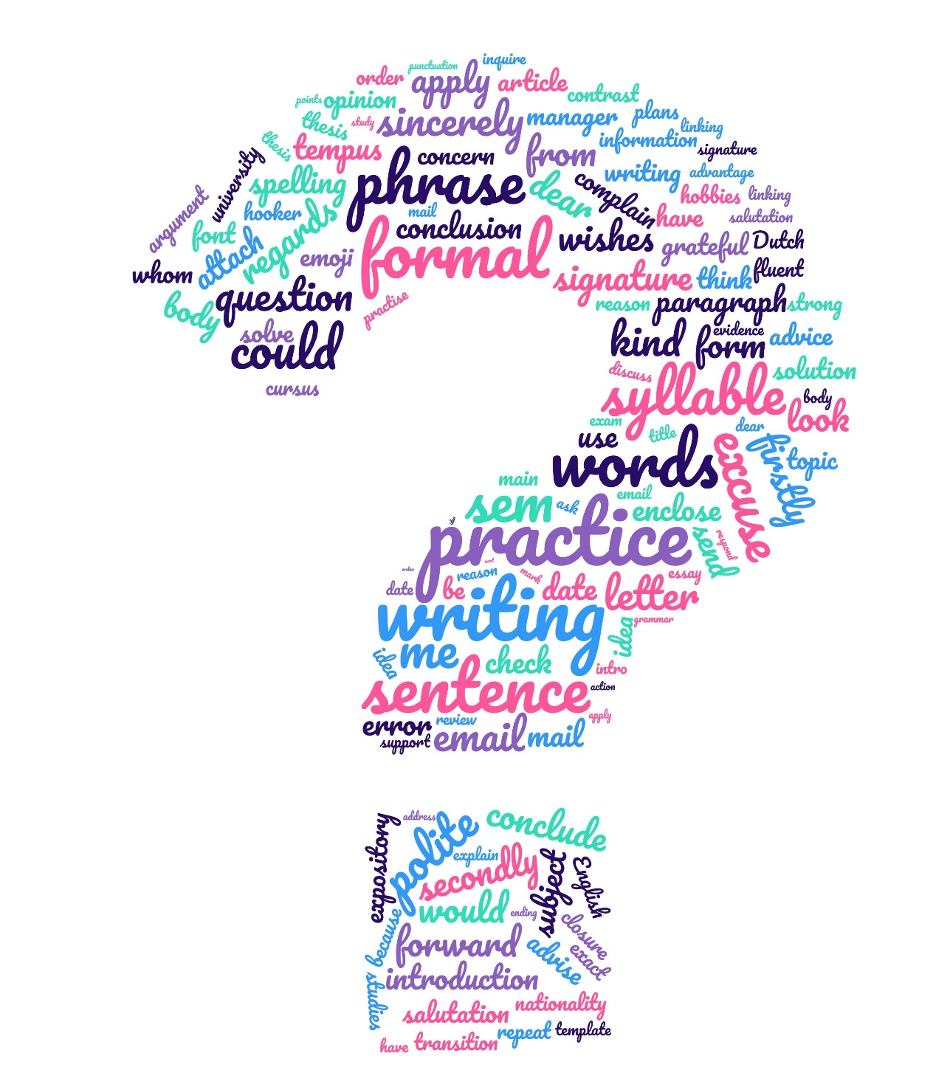

Your E-portfolio

One of your preliminary exams is your e-portfolio.
An e-portfolio is a collection of your work, showing your level of different skills. The skills in covers at our school are writing, speaking and reading. Some of the things you will have to do are also important for your next study. In this way we try to better prepare you for the next step.

Your e-portfolio should contain several items:
- Your best practice formal email
- Your best practice essay
- 1 short story
- 1 elevator pitch
- Your best text read out loud
- 2 book reports, only one of which may have a film version

Practical information:
- You can hand in your reading out loud, your elevator pitch by mail or in Teams, depending on your teacher.
- Book reports have to be done in the Study Centre.
- Practice emails, essays and your short story have to be done in the computer classroom and handed in in SOM.
- You can find more information on your e-portfolio on www.altenaengels.nl > Class A6 > A6 e-portfolio and in your PTA.

Make sure you hand in your assignments in time, it gives you extra credit. Once the deadline is reached, you will have 1 more week to get points in your e-portfolio for this specific part. After that you will get 0 points!
Book reports always need to be handed in, if you want to pass your exams…

Scoring
Assignment | Note/score | Number of points |  | Assignment | Note/score | Number of points
Practice formal email | 0 - 4 | 0 |  | Book report 1 | average | 1
 | 4,1 - 6 | 1 |  |  | merit | 2
 | 6,1 - 7 | 2 |  |  | distinction | 3
 | 7,1 - 8 | 3 |  |  | In time | +1
 | 8,1 - 10 | 4
 |  |  |  | Book report 2 | average | 1
Practice essay | 0 - 4 | 0 |  |  | merit | 2
 | 4,1 - 6 | 1 |  |  | distinction | 3
 | 6,1 - 7 | 2 |  |  | In time | +1
 | 7,1 - 8 | 3
 | 8,1 - 10 | 4 |  | Elevator pitch | average | 1
 |  |  |  |  | merit | 2
Reading out loud | refer | 0 |  |  | distinction | 3
 | average | 1 |  |  | In time | +1
 | merit | 2
 | distinction | 3 |  | Short story | average | 1
 | In time | +1 |  |  | merit | 2
 |  |  |  |  | distinction | 3
 |  |  |  |  | In time | +1
 |  |  |  | Total |  | 28

WRITING PRACTICE
In this part of the reader you will practice:
- Writing a formal email
- Writing an essay
- Useful sentences

Rules for formal emails

- Do pay attention to the subject line
Write a clear, concise subject line that reflects the body of the email. Avoid subject lines with general words like, ‘Hi’, ‘Touching base’ or ‘FYI’, and do not leave the subject line blank.

- Do use a proper salutation
‘Hi’ and ‘Hey’ communicate a lack of professionalism and maturity. Begin your email with phrases such as, ‘Dear Mr. Jones, Dear Ms. Jones, Dear Sir/Madam,… ‘Good Morning’ or salutations like that only if you have exchanged multiple mails before.

- Do use an introduction
In cultures like the U.S., the best practice is for the sender to introduce themselves by first and last name with some background information in the first few lines. For Example: Dear Ms. Mandell, My name is Sharon Jones, I am a student of ….. and I am writing to you about …. This is especially important when introducing yourself to new contacts and employers who want to know how you received their contact information.

- Don’t use humour and sarcasm
Emails can easily be misinterpreted through text without context. Humour is culture specific. Avoid both humour and sarcasm in emails as the recipient may be confused, or worse, offended.

- Don’t use informal language and punctuation
Business emails are initially formal so use formal language and, for example, no slang words, words in capital letters and exclamation marks. Choose a normal font, like Calibri or Arial. After you get to know the person you are mailing with, you can become more informal.

- Do pay attention to the cultural differences
Avoid miscommunication by keeping in mind your cultural differences. People from cultures like Japanese, Arab or Chinese want to get to know you before doing business with you, whereas people from cultures like German, American or Scandinavian, prefer to get to the point very quickly.

- Don’t use emojis
Those little winking, smiling icons are for text messages. They are inappropriate and unprofessional in a business email. Emoticons may divert emails to a spam filter of junk mailbox, and it can look immature and unprofessional.

- Don’t be negative
It’s inappropriate to email negative comments. An email in all uppercase letter indicates anger. These antagonistic messages cause awkwardness long after the email has been sent and received. If you must relay bad news via email, use objective words and state the facts. Face-to-face communication is best when relaying bad news.

- Do use a conversation closer
By letting the recipient know that a response isn’t needed, the email cycle doesn’t continue on in perpetuity. Close with ‘No reply necessary’, ‘Thank you again,’, Please let me know if I can be of further assistance’. If a response is required, specify what and when. End your email with a closing such as ‘Best regards’, ‘Sincerely’ or another appropriate phrase.

- Do use a signature block
Generally, it should include: your full name, title, the company name, contact information, including a phone number. (no longer than 4 – 6 lines). If, however, it is a letter of motivation or a cover letter, you only include your full name, email address and phone number. Don’t forget to include +31.

- Do proofread
Check and recheck for spelling and grammatical errors. These errors make you seem unprofessional and will reduce the likelihood that the email will be taken seriously. Email software comes with many professional tools such as spell check. Use them.

- Do double-check your attachments
When you attach a file, be kind enough to take a few extra seconds to paste in into the body of the email as well. This shows consideration to the recipient by saving them time and risk in opening attachments.

Do’s | Don’ts
Choose a good subject line | Use humour and sarcasm
Use a formal salutation | Use informal language and punctuation
Introduce yourself and your subject | Use emojis
Make paragraphs | Be negative
Pay attention to cultural differences | Use fancy fonts or formatting
Check and recheck spelling and grammar | Use coloured fonts
Check and recheck your attachments
Use a conversation closer
Make a signature block

Useful phrases in formal emails

Salutations first contact | Salutations after several email exchanges
Dear Mr. Jones, | Hi James,
Dear Ms. Smith, | Good morning/afternoon,
Dear Jamie Fox, (can be man/woman) | Dear team,
Dear Sir/Madam, | Hi All,
To Whom It May Concern: | Hello,
Dear Recruiter, | Dear Abby,
Dear Hiring Manager,
Dear HR Manager/ Personnel Manager,

Closing remarks without follow-up | Closing remarks with follow-up
Thank you for your patience and cooperation | I will send you additional information
Thank you for your consideration | I look forward to receiving your input
 | If you have questions or concerns, do let me know
 | I look forward to your reply

Simplest, most used/formal | Slightly more personal | More personal, you know the recipient well
Sincerely, | Best regards, | Warm regards,
Regards, | Cordially, | Best wishes.
Yours truly, | Yours respectfully, | With appreciation,
Yours sincerely,

Signature block  with company | Signature block  without company | Mind the  phone number
First + last name | First + last name | +31 6 12345678 OR
Occupation + company |  | 0031 6 12345678
Phone number | Phone number
Email address | Email address
Introduction | - I am writing in order to ….  - I am writing in connection with …. (the article/editorial/report)  - I have just read … the article titled … in Saturday’s paper, last month’s edition of…  - I am writing to ask/inquire about…  - I read/found your advertisement in …. and would like to…
Describing problems | - I would like to complain about  - I am afraid I have to make a complaint
Offering solutions | - One possible way to solve this problem is  - An alternative solution to this problem is
Expressing doubt | - I am not quite sure if  - It is not clear to me if
Expressing interest | - I am interested in  - I have been looking for …. for a long time  - I was very interested in your article/presentation/editorial
Making a request | - Would it be possible for you to  - I am writing to ask for advice  - I wonder if I could ask you to/for  - I would be very grateful if you could
Making suggestions | - I think we should  - I would suggest/recommend organizing  - It would be a good idea to

Scoring your email
Your email will be graded in the following way:
What | How | What is it
Conventions and form | 2 pts | - No / not the right salutation  - No / wrong subject line  - No /wrong closing remark  - No / wrong signature block  - No paragraphs  Pay attention to the do’s and don’ts
Contents | 2 pts | Do you have all the points are mentioned in the assignment? The more you miss, the fewer your points will be.
Language | 8 pts | Word use  Grammar  Spelling/punctuation | Wrong/missing word  All grammar mistakes  All spelling/punctuation | 1 mistake  ½ mistake  ¼ mistake
Tone | 1 pt | Is it formal and polite enough?

In General

In a formal letter, you use formal English. For example, you use:
‘I would like’………. instead of ‘I want’.
You are not allowed to use abbreviations:
‘ I would like’ and not ‘ I’d like’.
You are not ….. and not you aren’t/you’re not

You can never ever begin a sentence with one of these words:
# but # also # because # so # and
And:
1 No contractions are used in a formal email. (I am, instead of I’m)
2 Fill your sentences within the paragraph.
3 Mention all topics!
4 Mind the lay out of your paragraphs.
5 Don’t use ‘want to’, but ‘would like to’ in most cases.
6 Skip a line after each paragraph.
7 Please mind your punctuation, don’t use question and/or exclamation marks.
8 MIND YOUR WORD ORDER!!!!
9 Don’t ask direct questions, use “I would like to know….” instead.
10 Never use a colon (:)

How do you ask or say

Request:
- Inlichtingen sturen
- Een overnachting regelen in een hotel
- ons mededelen of alles in orde is
- afspraak te maken op 10 januari
- Wat denkt u? / Wat is uw mening?

Say:
- is goed bevallen/was leuk
- verontschuldigingen aanbieden
- een opleiding is niet vereist
- contact opnemen met mijn huidige baas/werkgever
- in uw advertentie van 8 april
- ik zou u erg dankbaar zijn als
- een paar weken geleden las ik…
- helaas ben ik mijn camera vergeten in het hotel
- omdat ik geen bankrekening heb…
- ik wil solliciteren
- de reden waarom ik naar deze betrekking solliciteer is…..
- ik sluit afschrift van diploma bij
- ik reageer in antwoord op email van 16 mei
- ik neem de baan/uw aanbod graag aan
- spijt me maar kan baan niet aannemen
- ik ben het eens/niet eens met uw beslissing
- ik ben van mening dat ze ……
- ik neem uw aanbod graag aan
- ik maak me bezorgd om de resultaten
- van harte gefeliciteerd met uw succes/benoeming

Frequently used phrases/sentences

- Referring to your advertisement …, I would like to apply for the job of …
- I was born on 24th March 2002
- I am a 17-year-old Dutch girl/an eighteen-year-old Dutch girl
- I have the Dutch nationality/I am Dutch
- I attend a grammar school /I go….. /I follow pre-university education /I study at …
- I am in the final year of …
- I hope to graduate from … this year/I hope to pass my exams this year
- My hobbies are reading, playing the guitar, listening to music …. (in een opsomming alles dezelfde vorm)
- I like playing volleyball, helping children … (na like, hate de –ing vorm/gerund)
- After my graduation I would like to …
- Vacation = Amerikaans/holidays = Brits (summer holidays = mv)
- I have to go into rooms/into lodgings (op kamers gaan)
- The job fits in with my future plans/fits into my future plans/suits my future plans
- I am good at speaking English / My English is very good / I speak English very well / I speak English fluently
- Do I have to take out any insurance? (assurance = vooral levensverzekering)
- I was also wondering …, Perhaps you could also tell me …, Another thing I would like to know is …(voor de variatie)
- Furthermore … (niet Further)/Finally …
- In if-zin geen will of could (niet beleefd genoeg)
- In zinnen die beginnen met if krijg je any, niet some (If you have any questions)
- If gebruik als iets niet zeker is. When gebruik als het zeker is.
- By yourself = alleen, yourself = zelf
- In ontkennende zin not either. I do not know the answer either
- Naar de universiteit/ziekenhuis gaan = to go to university/hospital
- Bij datum the en of niet schrijven, alleen uitspreken (I left on 24th May)
- It happened on July 6th at about 10 o’clock.

Common mistakes to avoid

a / an | - an - gebruik je als het volgende woord in de uitspraak met een klinker begint (a,e,i,o,u).  - a - gebruik je in de andere gevallen
Vul in : a / an.
1. opinion 6. expensive car
2. European country 7. hour
3. helicopter 8. unit
4. one-way- street 9. FBI-agent
5. useful tool 10. hospital

to / too | - too = te / ook  - to = om te/ naartoe/ het hoort bij het werkwoord
Vul in: to / too
1. The firm sells printers, but offers technical support, too.
2. It's important ____ consider all the implications before making a decision.
3. He hoped ____ finish the project, but he had ____ many distractions.
4. The product was ____ expensive for students ____ acquire for their new studies.
5. It's important ____ practice daily if you want ____ get better, but do not push yourself ____ hard.

Adverbs of frequency:  always, usually, seldom, etc. | - Sentences with one verb (except for `be’).  - In front of the main verb. (They never sleep outside.)  - Sentences with two or more verbs.  - in front of the last verb. (She has already seen the film.)  - Sentences with one verb (`be`)  - Behind forms of `be`. (He is always late.)

Put the adverbs in the right place.
- I go to the gym in the mornings, but on weekends I prefer to sleep in. USUALLY
- Even though it's a popular tourist destination, she has visited the Eiffel Tower. SELDOM
- It's impossible to find tickets for the concert now since they sold out within minutes. NEARLY
- They eat out on Fridays as a way to celebrate the end of a working week. ALWAYS
- We meet for brunch; it's our little tradition every month. OCCASIONALLY
- Though he owns a car, he takes the bus to work because he believes in reducing his carbon footprint. OFTEN
- There's a bakery nearby that is visited for their fresh croissants. REGULARLY
- She's late for meetings, which frustrates her team members. RARELY
- Students attend the Monday lectures, but the turnout is lower on Fridays. SOMETIMES
- It's known that consuming too much sugar can lead to various health issues. WIDELY

Place and Time | - Place before Time at the end of a sentence  - I went to Amsterdam yesterday.  - Time can also be placed at the beginning of a sentence  - Yesterday I went to Amsterdam.
Make into a good sentence, do not forget to use all words
- are going to – We – tonight – each other – in front of – meet – the sports centre
- often - travel - children - during - holidays - the - summer - to - France - the.
- do – today – will – your homework – in the kitchen – You – have to
- was – his lessons – studying – He – last night – in the drawing room
- have – will – my homework – I – finished – before ten
- him – have to – I – at the station – shall – the ticket – give – tomorrow
- been – stay – have – for some days – We – obliged to – at home
- this - never - before - seen - in - location - has - exhibition - an - been.
- in - office - afternoon - his - every - she - the - visits.
- in - morning - will - the - room - the - at - eight - meet - we - assembly.
- shall – you – next Saturday – I – the money – pay
- normally - in - town - that - they - once - eat - restaurant - a - year - at.
- in - once - her - twice - a - to - office - goes - he - week.
- annually - conference - in - the - participate - London - I.
- time - works - in - the - summer - garden - he - every - his - at.
- at the night school – Sharon – a yoga class – next month – is going to – join

plural | - General rule: word+s book - books  - Ending in a ‘sis’ - sound: word+es watch - watches  - Ending in consonant +y: word (–y)+ies, baby – babies  - But: boy – boys  - Ending in –f/ - fe: word ( - f/fe)+ves thief – thieves
- Irregular forms: foot - feet
man - men
woman - women
mouse - mice
fish - fish

Make plural.
1. country 6. street
2. knife 7. woman
3. sandwich 8. goose
4. a pair of trousers 9. basket
5. chair 10 people (volk)

Genitive | - ‘s for people, animals and time expressions  - The cat’s house, my parents’ car, yesterday’s paper  - of for objects  - the roof of the house

Underline the correct possibilities
- This week’s charts / the charts of this week
- The street’s end / the end of the street
- My sister’s books / my sisters’ books / my sisters’s books / the books of my sister
- The match’s result / the result of the match
- Charles’ hair / Charles’s hair
- The children’s behaviour / the childrens behaviour / the behaviour of the children
Adjective or adverb
- An adjective is a word or set of words that modifies (i.e., describes) a noun or pronoun. Adjectives may come before the word they modify.
- An adverb is a word or set of words that modifies verbs, adjectives, or other adverbs. Adverbs answer how, when, where, why, or to what extent—how often or how much
- No change with verbs of senses and linking verbs and some adverbs do not take -ly
- He is a ________ (quick) learner and picks up new skills effortlessly.
- The teacher explained the concept ________ (clear).
- The soup tastes ________ (wonderful), thanks for preparing it.
- She sang the song ________ (beautiful) during the concert.
- The movie was ________ (incredible), I'd recommend it to everyone.
- He completed the marathon _______ (impressive), considering it was his first time.
- The children were playing ________ (noisy) in the garden.
- The view from the mountaintop is truly ________ (breathtaking).
- She answers the questions _______ (honest), even if it might upset someone.
- Despite being expensive, the watch looks ________ (cheap).

Practice makes perfect

1 Put one suitable word in each space.
Unlikely as it may seem, there has now been expert confirmation that wild pumas and lynxes are (1) ..at…large in parts of Britain, rather than being the figments (2) …………some wild imaginations. Previous sightings (3) …………such large cats had been put down (4) …………exaggeration. (5) ………all, the argument went, some people are prone (6) ………seeing flying saucers and Loch Ness monsters, particularly when (7)……… the influence of one drink too many. Some newspapers were suspected (8) …………having made (9) …………stories such as that of the Beast of Exmoor, an animal which is responsible (10) …………the deaths of hundreds of sheep over the past ten years. But experts have now come (11) …………with proof that such stories were (12) …………earnest after all. The animals are (13) …………all likelihood pets which have escaped (14)……… small zoos, or been abandoned (15) …………their owners. Because the keeping (16) …………such animals is severely restricted (17) …………the terms of the Dangerous Wild Animals Act of 1976, owners of unlicensed animals might not report an escape (18) ………… fear of prosecution. Britain's only surviving native species, the wild cat, is confined (19) …………Scotland. After examining hair samples, experts now say that the Beast of Exmoor in the South of England is (20) ……… doubt a puma or lynx, both of which are normally native to the Middle East and Asia.

- Complete the second sentence so that it has a similar meaning to the first sentence, using the word given. Do not change the word given.
  - You think I am someone else.
confusing
You are …. confusing me with........................ someone else.
  - Gary is proud of the fact that he is never late.
on
Gary prides being early.
  - On this ship, passengers cannot get onto the bridge.
access
Passengers have the bridge of this ship.
  - What is the difference between nuclear fission and nuclear fusion?
differ
How exactly nuclear fusion?
  - An electrical failure was said to be the cause of the fire.
blamed
They an electrical failure.
  - It's all a matter of money, in the end.
comes
It all in the end.
  - His smooth manner didn't deceive us.
taken
We were his smooth manner.
  - The total came to just under £4,000.
worked
The total just under £4,000.

- Using the notes as a guide, complete the letter. Use one or two words in each space. The words you need do not occur in the notes.
We've had a letter from a Mr Scott, complaining about a rather violent scene which upset his children, on one of our programmes, 'Murphy's Run'. Could you write to him? Point out that:
- The programme is a joint production with Talent Productions.
- It observed Channel 2 regulations.
- All programmes, no matter where they come from, are checked 3 months before they're shown.
- The TV Standards Authority often checks children's programmes and were happy with the scene Mr Scott didn't like.
- Unlike similar programmes on other channels, it's very suitable viewing.
- We always try to show clearly the difference between good and bad on it.
Dear Mr Scott,
With (1) ..reference/regard.............................. to your letter of 3 May, we deeply regret the distress caused to your children by the violent scene on episode 53 of 'Murphy's Run', a Channel 2 programme produced in ………..…(2) Talent Productions Ltd.
However, the ……… (3) with Channel 2 regulations. Each programme is carefully checked for unsuitable material three months in …………….(4) its scheduled broadcast time. This ……………(5) to all Channel 2 programmes ……………..(6)
of their origin and type. There is also a watchdog body, the TV Standards Authority, which monitors children's programmes on a ……………..(7) They too were happy with the scene you (8) ……………………….. The programme in question is, in (9) ……………………….similar programmes on private channels, entirely suitable for children, and takes great care to (10) between good and bad, and between moral and immoral.
In conclusion, we are happy that the scene was acceptable, and we hope that you will continue to allow your children to watch the programme.
Yours sincerely,
Ann Orbison

Practice email writing

Aanwijzingen voor alle e-mails:
- 240 woorden minimaal. 300 woorden maximaal.
- Gebruik Calibri, 12pt, line spacing 1.5
- Noteer het aantal woorden links onderaan.
- Na elke opdracht een nieuwe alinea.
- Er wordt niet alleen gelet op je Engels maar ook of je email een goedlopend geheel is.

Checklist email

This checklist may help you in evaluating your email. Tick the boxes to see if you have done all you need. Your use of Language will be more difficult to evaluate. Make sure you check as good as you can.
Conventions | 2pt | Contents | 2 pt
Subject line |  | Did you miss any items?
Salutation |  | Closing remark
White line/paragraphs
Closing |  | Tone | 1 pt
Signature block |  | Direct questions
 |  | No informal language and punctuation
Amount of words |  | Formal in general
 |  | No contractions (I’m, etc.)

Formal email 1 : report
Situatie
De University of Glasgow - www.gla.ac.uk - heeft een project opgezet om het gebruik van de computer in het onderwijs te bevorderen. Onderdeel van dit project is een inventarisatie van de mate en manier van computergebruik in het onderwijs in de landen van Europa op dit moment. Men is met name geïnteresseerd in de ervaring op dit gebied van de leerlingen zelf en heeft hen via een prijsvraag uitgenodigd verslag te doen van hun gebruik van de computer op school en thuis. Men is ook zeer benieuwd naar suggesties en ideeën. De aardigste besprekingen worden beloond met een prijs – een weekje Glasgow. Je dingt mee met een email onder de titel: The computer: a useful educational tool? Je stuurt een email aan Professor Calder PhD (ProfCalder@uog.org), Head of Computing Science Department at the University of Glasgow.

Opdracht:
- Begin je email met een verwijzing naar de uitnodiging een verslag in te zenden.
- Geef een persoonlijke introductie – naam, leeftijd, geslacht, nationaliteit, opleidingsniveau, bezigheden en plannen voor vervolgstudie.
- Beschrijf hoe er op jouw school met de computer wordt omgegaan en noem daarbij ten minste twee zaken – o.a. apart vak?, alle leerjaren?, aparte computerlokalen? Geef hierbij ook je oordeel.
- Vertel wat je thuis op de computer doet en wat je daarbij het nut van de computer vindt. Noem minstens 2 dingen.
- Geef tot slot kort en krachtig antwoord op de vraag die in de titel werd opgeworpen.
- Sluit je brief af.

Formal email 2: letter of motivation
Situatie
Je hebt een studie uitgezocht waarvoor een selectieprocedure is. Een van de onderdelen van de procedure is een motivatiebrief. Omdat het via een digitaal platform van je vervolgopleiding gaat, is het in de vorm van een formele email. Het is een heel belangrijk onderdeel van de selectie dus probeer zo persoonlijk mogelijk te zijn in je toelichting. Zoals je weet is het in een motivatiebrief extreem belangrijk om zo weinig mogelijk fouten te maken dus controleer je email goed.
Inhoud:
- Waarom je denkt/vindt in aanmerking te komen voor de opleiding
- Wat je beweegredenen zijn om dat te willen
- Schrijf je motivatie en ambitie
- Je brief moet zich ‘onderscheiden’ van de andere briefschrijvers
Elementen in een motivatiebrief (personal statement)
- Persoonlijke gegevens
- Korte beschrijving van wat je hebt gedaan
- De reden waarom je juist deze studie wilt volgen en geen andere
- Persoonlijke activiteiten
- Waarom de studie in die stad? Waarom aan die universiteit/hbo - instelling?
- Waarom jij geschikt bent voor studie en beroep
- Wat zijn je sterke punten?
- Hoe houden je vooropleiding en andere activiteiten verband met je studiekeuze?
- Wat zijn je toekomstplannen?
Tips en aandachtspunten:
- Zorg voor correct taalgebruik.
- Gebruik korte, actieve zinnen en schrijf wel formeel maar niet te formeel.
- Beschrijf alle feiten op de STAR methode: Situatie – Taak – Actie – Resultaat.
- Volg de AIDA formule, waarmee je de aandacht trekt van de lezer, zijn interesse wekt, een desire teweegbrengt en hem aanzet tot actie.
- Bedenk dat normaal gesproken een motivatiebrief langer is (400 – 750 woorden) dan hier op je tentamen gevraagd wordt, dus wees beknopt in je beschrijvingen.

Formal email 3: Letter to the editor

Situatie

In de internetuitgave van een Engels dagblad word je aandacht getrokken door een artikel met de kop "Hotel Mommy". Daarin wordt beweerd dat in Nederland tegenwoordig veel jongeren langer bij hun ouders blijven wonen dan voorheen. De auteur betoogt dat er bedenkelijke kanten aan zitten: jongeren worden op deze manier wel heel laat volwassen, en het worden verwende mensen zonder eigen verantwoordelijkheidsgevoel. Zelfs suggereert hij een verband met toenemende criminaliteit en toenemend drugsgebruik. Lezers worden uitgenodigd om via internet te reageren. Dat besluit je te doen. Je schrijft je email aan de hoofdredacteur van The Daily Telegraph (editor@dailytelegraph.co.uk)

Opdracht
- Verwijs naar de publicatie waarop je reageert en geef aan waarom je reageert.
- Stel jezelf voor (naam, leeftijd, geslacht, nationaliteit en opleiding)
- Geef een verklaring voor het feit dat "veel jongeren langer bij hun ouders blijven wonen". Werk minstens twee mogelijke redenen uit (bijvoorbeeld kamernood, hoge studiekosten).
- Geef daarbij ook aan welke rol jij voor de overheid ziet in het geheel.
- Protesteer tegen twee beweringen van de auteur. Onderbouw je mening met argumenten.
- Geef je reactie een passend slot.

Formal email 4: Cover letter

Op Internet heb je de volgende oproep gelezen:
Movie Theatre
Free movies, free popcorn, and socializing are just a few of the benefits you get when working at a movie theatre. If you are a movie buff, this is the perfect environment for you to spend your summer working hours. Concessions, tickets sales, ticket stubs, and usher are a few of the positions you can choose from. You can choose to beat the heat during hot summer days, and maybe catch a free flick at night.
Mail to the local manager Ted Mosby (movietheatre@ODEON.co.uk)
Opdracht
Dit lijkt je wel iets voor de komende zomer en je besluit een email te sturen waarin je het volgende verwerkt:
- Vertel waar en wanner je de advertentie hebt gelezen. Zeg waarom je mailt.
- Vertel iets over jezelf: naam, leeftijd, geslacht, nationaliteit. Zeg dat je nog op school zit. Noem het schooltype. Zeg welke talen je spreekt.
- Zeg waarom je deze baan graag zou willen hebben: je houdt van films bekijken, je kunt goed met mensen overweg, je kunt goed samenwerken, je ontmoet graag mensen uit andere landen,
- Het lijkt een ideale combinatie van werk en vakantie, je wilt je Engels verbeteren, etc.
- Noem minimaal 2 andere eigenschappen die jou geschikt maakt voor deze baan en licht ze toe.
- Vraag de volgende inlichtingen: verdien je iets? Is het een probleem dat je niet Engels bent? Van wanneer tot wanneer kun je precies terecht?
- Vraag naar accommodatie. (bijv. zelf regelen of niet)
- Zorg voor een passend slot.

Writing an Essay

General information:
- Your essay should be between 350 – 450 words
- You are not allowed to use any extra information, so nothing coming from the Internet or other sources. We want to see your own English and the subjects will be clear, so you can write about them without extra information.
- Your paper will be judged on:
  - Content organization (20 points)
  - Grammatical range and accuracy (40 points)
  - Lexical range and accuracy (20 points)
  - Coherence and cohesion (20 points)
- You are given more than one statement to choose from and sometimes possible arguments
You will have to write either:
- An expository essay: This looks like the Dutch beschouwing.
E.g. What are the advantages and disadvantages of living in the countryside?
- An opinion essay: This looks like the Dutch betoog.
E.g. Smoking should be banned in all public places, including bars and restaurants. Discuss.

Expository Essay Format
Introduction
- Hooks the reader and captures his or her attention
- Contains the thesis/topic sentence of the essay
- Briefly states 3 or more main ideas which will be explained in the body of the paper
Body
- Contains 3 or more fully developed paragraphs
  - One paragraph to support each main idea stated in the introduction, in the same order
  - Your strongest argument first
- Each paragraph contains a single, declarative topic sentence and at least 3 or 4 supporting detail sentences
- Transition words and phrases help move the reader from one idea to the next
  - also
  - in addition
  - another reason, etc
Conclusion
- Brings closure to the essay
- Briefly restates the main ideas (without repeating the exact words in the introduction)
- Must end with a strong statement or an appeal to the emotions

Persuasive/Opinion Essay Format
Introduction
- Hooks the reader and captures his or her attention
- Both sides of the opinion
- Your opinion
- Briefly states 3 reasons which will be explained in the body of the paper
Body
- Contains 3 or more fully developed paragraphs
  - One paragraph to support each reason stated in the introduction, in the same order
  - Your strongest argument first
- Each paragraph contains a topic sentence and at least 3 or 4 supporting detail sentences
- Transition words and phrases help move the reader from one idea to the next
  - also
  - in addition
  - another reason, etc
Conclusion
- Briefly sum up the reasons (without repeating the exact words in the introduction)
- MUST point out solution or call for action, giving the reader a sense of ending

Linking words
Addition | Sequence | Consequence | Contrast
Above all,  Furthermore,  In addition to,  As well as,  Likewise,  Moreover,  Not only – but also  Similarly, | Firstly,  Secondly,  To begin with,  Another reason  Another advantage  Finally,  Lastly, | Therefore,  As a result,  Consequently,  Because of that,  Because of  so | On the one hand,  On the other hand,  Nevertheless,  However,  Although  Instead of  In contrast,  Despite
Opinion | Reason | Condition | Summary
(In my opinion,)  In the opinion of,  (Un)fortunately,  Certainly,  Obviously,  Of course | Since  Due to  Owing to  In order to  Because | If  Unless  Whether  Provided that | In conclusion,  To conclude,  Taking all these points into consideration,  All things considered,  In short,  To sum up

Title Case
It is convention to capitalize the first word, last word and ‘principal’ words in essay titles.
The principal words are all words except for:
Articles | Conjunctions | Prepositions
a, an, the | Examples:  and, or, but | Examples:  in, with, by, of, on
- Holding on to School Uniform Traditions
- Saving Pocket Money Pays Off
- The Practice of Capitalization in Essays Seems Ridiculous

Practise paragraph writing
H.O.T
introduction paragraph

Writing a good introduction is very important. Look at this template for a good expository essay introduction:
Hook | Engage your reader with a Hook:  - Rules of three  - Definition of a word  - Analogy  - Describe a scene | - Famous quote  - Fact or statistic  - Song lyrics  - Interesting sentence
Overview | Provide an overview of the topic of the paper.  State any needed background information.
Thesis | State your position/argument. Do NOT use first person  List your 3 talking points

The conclusion is also very important:
Summary | Summarize your points from paragraph 2, 3 and 4.  Do NOT introduce new arguments/reasons
Thesis/opinion | Restate your thesis statement / repeat your opinion in different words
Closing sentence | You MUST choose a closing sentence that gives the reader something to think about or call them to action  In persuasive/opinion essay you can provide a solution

Expository writing template
Title:
Introduction
Attention getter
Thesis statement
Conclusion
Introduction/ body
Third argument

Second argument

support
Support
Support
First argument

Review of arguments and possible solution/actions

Persuasive writing template
Title:
Introduction
Topic
Opinion/Point of view

Scoring your essay:
Conclusion
Introduction/ body
Third reason

Second reason

Evidence

Evidence

Evidence

First reason

Review of reasons and possible solution/actions

Here you can see how your essay is scored. In each column the lowest mark counts. So, for example, if you forget your title, no matter how the rest of your organisation is done, you score 0 points.
It is important to work on your grammar and idioms because they count for 60% of your note. If you want to see how you score on these skills or practise, go to www.altenaengels.nl and look up A6 writing page. Here you can find tests and exercises for B2 – C1 level.
For your vocabulary you can go to AUTOMATIC READABILITY CHECKER, a Free Readability Formula Consensus Calculator (readabilityformulas.com) and insert your own written text. You will see your level immediately.

band | Content organisation and task response | Coherence and cohesion | Grammatical range and accuracy (2x) | Lexical range and accuracy
20 | - Fully addresses all parts of the task  No errors in structure:  - Good introduction and conclusion  - Thesis/opinion clear  - Good original title  - Good topic sentences | - Sequences information and ideas logically  - Uses a variety of cohesive devices without error (min 4)  - Skilfully manages paragraphing  - Arguments well worked out | - Uses a wide range of structures with accuracy  - Rare minor errors occur only as ‘slips’  - Shows masters level (C2) | - Uses a wide range of vocabulary naturally  - Rare minor errors occur only as ‘slips’  - Formal language used everywhere  - Shows masters level (C2/grade 12)
15 | - The structure is generally correct but not completely  - Presents and supports main ideas although the conclusions may become unclear or repetitive  - Opinion/thesis is present but not very clear  - Only two good topic sentences | - Uses a range of cohesive devices appropriately although there may be some under - /over - use (3)  - May not always use referencing clearly or appropriately  - Minor errors in cohesive devices | - Uses a sufficient range of structures with accuracy  - Has good control of grammar and punctuation but makes a few errors  - Produces frequent error - free sentences  - Shows proficiency level (C1) | - Uses an adequate range of vocabulary  - Attempts to use less common vocabulary but with some inaccuracy  - Minor errors or informal language  - Shows proficiency level (C1/grade 11)
band | Content organisation and task response | Coherence and cohesion | Grammatical range and accuracy | Lexical range and accuracy
10 | - More than one error in essay structure  - Some parts of the task may be over - generalised and/or supporting ideas may lack focus  - Presents some main ideas but they are difficult to identify and may be repetitive, irrelevant or not well - supported  - Opinion/ thesis statement very unclear or hardly recognizable  - Wrong type of essay | - One argument not well worked out  - Uses basic cohesive devices but inaccurately or repetitively (2)  - Presents information and ideas but not arranged coherently | - Uses only a limited range of structures  - Attempts complex sentences but these are often incorrect  - May make frequent grammatical errors and punctuation may be faulty  - Only advanced structures are used (B2) | - Uses a limited range of vocabulary but this is minimally adequate for the task  - May make noticeable errors in spelling and/or word formation that causes difficulty for the reader  - Shows advanced level (B2/grade 10/9)
5 | - Hardly any structure  - No originality at all in the title  - No opinion/thesis statement present  - One good topic sentence | - Two arguments not well worked out  - Has very little control of organisational features  - Does not organise ideas/ wrong order paragraphing  - One cohesive device used | - Attempts sentences forms but errors in grammar and punctuation predominate and distort the meaning  - Only intermediate structures are used (B1) | - Uses a limited range of words and expressions not adequate for the task  - Errors may severely distort the message  - Shows intermediate level (B1/grade 8)
0 | - No structure  - No title  - No good topic sentences | - Three arguments not well worked out  - No organisational features  - Incomplete/no /wrong paragraphing  - No cohesive devices used | - Grammar is so faulty that it hardly makes any sense  - Lots of faulty punctuation  - Only pre - intermediate level structures are used (A2) | - Uses a very limited range of words and expressions  - Native speakers cannot understand what is meant  - Shows pre - intermediate level (A2/grade 7)

Practice Use of English and linking words

1 Underline the correct word or phrase in each sentence.
a) A: Did you ring the hospital for me?
B: I forgot as a result/to be honest/to make matters worse. I'll do it now.
b) A lot of adults are very wary of learning in a school situation. For that reason/On the other hand/To tell the truth they don't sign up for our courses.
c) By and large/Despite the fact that/Owing to I'm very pleased with their work on our home. At any rate/'Accordingly'/Having said that, I think they could have made a better job of the painting.
d) I missed two weeks' training because of flu last month. To put it another way/As a result/To tell the truth, I'm not expecting to run very well in today's race.
e) They've had a very difficult time. On top of that/At any rate/To start with, their home was burgled.
f) What a terrible experience! Anyway/In contrast/By the way, you're safe now that's the main thing!
g) She's a sociable girl with lots of friends. Even so/Furthermore/To some extent, she can get lonely, like anyone else.
h) He comes across as being very full of himself, in contrast/broadly speaking/whereas he's actually a very nice guy.
i) Nonetheless/On the whole/Hence I agree with what you're saying, but I'm not sure about your last point.
j) I seem to be giving the impression that I didn't enjoy my time in Norway.
After all/Having said that/On the contrary, I had a wonderful time.

2 Underline the most suitable word or phrase to complete each sentence.
a) They've got a terrible record over tax and education. Nevertheless/On the other hand, I still think the Democrats will win the election.
b) Balding's 'People in the Sky' is a very disappointing painting. At any rate/In contrast, Rae's 'Beach Scene' really brings this exhibition to life.
c) I would like to complain about the way I was treated in your shop. For one thing/Besides, the assistant was rude ...
d) Our dining room is a place which we keep strictly for eating, as opposed to/whereas the sitting room, which is for sitting, talking and watching TV.
e) We saw the Eiffel Tower, the Seine and the Louvre, what's more/as well as Euro Disney.
f) The country's economy depends to a large extent/at least on the tourist industry.
g) I'm here on business in addition/as opposed to pleasure.
h) The weather is likely to be dry and warm. In the far north - west of Scotland,
however/whereas, it will be wet and windy.

Punctuation
• Commas
Commas are used to separate items in lists, before question tags, to separate clauses, after and around certain linking words.
- I've been to Dallas, New Orleans, Kansas and Tampa Bay.
- Sue is a lovely girl, isn't she?
- If you see Kevin, tell him his photocopies are ready.
- Broadly speaking, I agree with what you are saying.
- I do not, however, agree with your last point.
Note that commas are not used between a subject and its verb, or in defining relative clauses.
- The lady standing over there at the bus stop is my next - door neighbour.
- Will the pupil who threw that paper dart please stand up now.
• Apostrophes
Apostrophes are used to indicate letters omitted, possession and plurals of letters and figures.
- Letters omitted: It's warm today.
- Possession: Jack's car, the player's entrance, the people's decision Possessive its does not have an apostrophe.
- Plurals: There are two I's in 'specially'. Are these 7's or 3's?
• Colons and semi - colons
Colons introduce examples, lists, and statements which give in detail what has been stated in general.
- There were two possible courses of action: borrowing from the bank, or asking for more time to find the money elsewhere.
- Semi - colons divide parts of long sentences or long phrases in a list; it is usually possible to divide one sentence into shorter ones, so that semi - colons are unnecessary.

Practice interpunction

1 Add the necessary commas, (semi) colons and apostrophes to these texts.
I've been to the following Italian cities Rome Florence Genoa and Pisa. I thought Rome was incredible the food was great the views were fantastic and I will never forget the vivacious people. The Italians' legendary hospitality was nowhere more evident than in the capital city. But my all - time favourite is probably Genoa with its fabulous hill - top houses and its dusty mountains reverberating to the sound of grasshoppers. I spent many a happy hour looking down on the seething city below and the sea beyond. Best of all the city's location at the heart of the Italian Riviera meant that fabulous resorts like Portofino and Camogli were only a train ride away.
Water is becoming a more and more precious commodity so save as much as you can. Flushing the toilet accounts for a third of all household water use so don't flush wastefully. If you are only getting rid of a tissue for example resist the habit of reaching for the handle or chain. Take a shower rather than a bath it uses about a third of the water. And don't keep the water running all the time when you wash or clean your teeth. If you have a garden try to find ways of saving water outside such as using a water butt to collect rain water rather than using a hosepipe to water your flowers. A simple pipe connecting external gutters to a water butt can save an awful lot of water.

2 In most lines of this text, there is either a spelling or punctuation error. For each line, write the correctly spelled word, or show the correct punctuation.
The common cold, as it is technicaly known, still resists the efforts of science to control and cure it, and has given rise to a rich popular mythology. As the name suggests the assumption is that you catch a cold because you go out in the cold or get we As we now that a cold is a virus, and that we actually catch it from being in contact with others', this is not strictly true. Shakeing hands with people, kissing them or just being in the same room, can pass on the virus. It is now generally beleived that cold viruses; and there is more than one type, are always present in the throat, but only become active when the bodys resistence to infection is lowered. The activated cold virus then attacks the membranes in the nose and throat, who's tissues become weakened and thus suseptible to infection by types of bacteria which are generally also present in the body. Sudden chilling, or getting soked to the skin, promote conditions in nose and throat membranes that permitt the cold virus to invade the body, although some individuals seem to be resistant to this. Just being out in the cold is not enough, and studys conducted in wartime among troops living in the open found that the incidence of colds' was no greater. As far as prevention and cure are concerned, nearly everyone has there own favourite remedy. Doctors have been unable to produse an affective vaccine against colds, although strong claims have beer put forward for vitamin C.

Planning paragraph writing

Think about the following subject: Americanisation versus Europeanisation. Try to give your opinion on this subject and come up with arguments supporting your opinion.
What points are you going to discuss? Write these down telegraph style. Add your arguments in the same manner.
Now, you are ready to start writing your body (your opinion, ideas and arguments).
First, write down your main ideas using linking words in a complete sentence. This should be done in a concise manner. No arguments should be in your opening sentence.
Second, let another student check your main sentences. Is it concise? Is it a complete sentence? Is your idea clearly written down? Are linking words used?
Once you have received feedback on your main sentences, make any necessary adjustments. Done? You can continue with supporting your ideas with arguments.
Now, complete your ideas using different arguments that support your idea. No new ideas should be mentioned, only arguments that support your main sentence.
Next, again, let another student check your entire paragraph. Again, is it concise? Are these complete sentences? Do the arguments support the main sentence of the paragraph? Is the correct tense used?

Now, try again with the following subject:
The Black Lives Matter movement has lost its objective.

Essay statements used in former exams to practise
- Every student should take a gap year after secondary school. Discuss the advantages and disadvantages
- More and more sophisticated medical research and discoveries mean that people will live much longer in the future. This development will have a devastating effect on society in the long term. Discuss. (Anglia Masters essay)

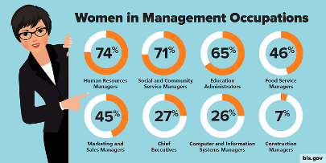
- Top jobs should be equally divided between men and women. Discuss.

- The world would be a better place if every school child aged 12 or older had to do 50 hours of unpaid work to help his community. Outline the advantages and disadvantages of this.

- Artificial Intelligence is a serious threat to life as we know it today.

- ‘Work - place apprenticeship schemes where young people can train while they earn a qualification are as valuable as more traditional academic university degrees.’ To what extent do you agree or disagree? (Anglia AcCEPTproficiency essay)

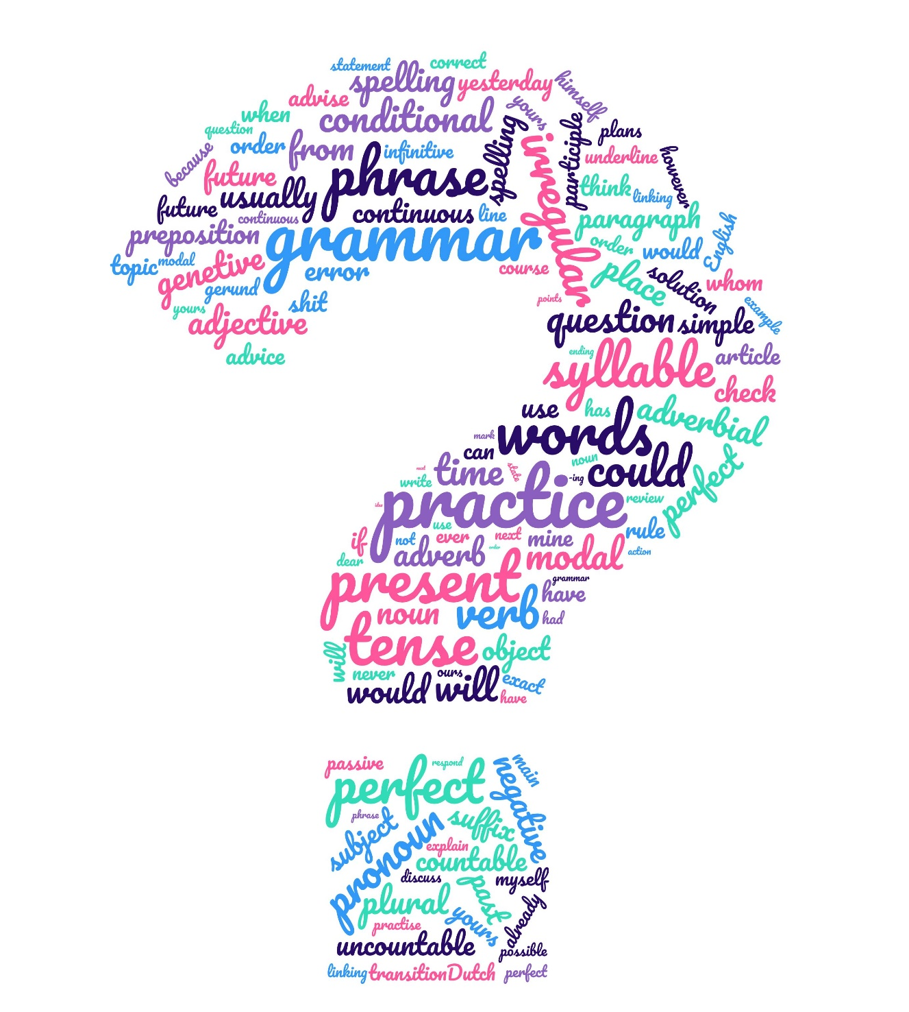
GRAMMAR PRACTICE
In this part of the reader you will practice:
- Tenses
- Passive
- Articles

Verbs in formal letters
Choose from the tenses below
Present Simple Present Continuous Past Simple Past Continuous
Present Perfect Present Perfect Continuous Past Perfect Passive

Tenses mix 1
1. The bottles (fill) _______________ before the labels are put on.
2. I (drive) _______________ to work every day.
3. She (come) _______________ last Friday.
4. Who (talk) _______________ to? Oh, that’s her brother.
5. English (speak) _______________ all over the world.
6. My friend (paint) ______________ the door when someone (come) _________ in.
7. I (not see) ________ John for ages. I don’t know what (happen) ________ to him.
8. My grandma (knit) ______________________ the whole day. She loves it!
9. Two of my crystal glasses (already break) _______________ !
10. Shall we go for a walk? No, it (still rain) _______________ .
11. The tickets (post) _______________ to you more than a week ago.
12. I didn’t lose it. It (steal) _______________ !
13. I (play) _______________ tennis from 3 till 4 yesterday afternoon.
14. In Britain they (drive) _______________ on the left.
15. Where’s Tom? He (smoke) ______________ cigarette outside.
16. I first (meet) _______________ him ten years ago.
17. Vegetarians (not eat) _______________ meat.
18. All the rooms (not clean) _______________ yet.
19. He had a heart attack. He (take) _______________ to the hospital yesterday.
20. Where (you go?) _______________? Come back!
21. That painting of Rembrandt (still admire) ___________ by lots of people.
22. Jack (do) ____ his homework when Susie (ring) _______ and asked him out.
23. After the fox (eat) _______________ the rabbit’s carcass, it went away.
24. His ankle (break) _______________ in a skiing accident.
25. He never (arrive) _______________ on time.
26. I (study) _______________ at school, but I (forget) _______________ most of it
now, because I (never have) _______________ the chance to practice it.
27. (Anyone sit?) _______________ here? No, no, sit down.
28. The Seine (flow) _____ through Paris.
29. We (see) ______ a lot of rubbish when we (walk) _______ through the park.
30. It (always rain?) _______________ so much here?
31. They (know) ________ each other since they (be) ______ at school together. They (always be) _______________ very good friends.
32. The building at St. Antoine (formerly use) _______________ as a prison.

Tenses mix 2
34. I (have) _______ this dress for ages. I (wear) ______ it many times. I (buy) ____it when I (go) ____________ to New York a few years ago.
35. I (not see) ___ Tom in the office yesterday. Do you know where he (be?)___?
36. He (stay) _______________ at this hotel last year.
37. I sometimes (take) _______________ the nine o’clock train to Amsterdam.
38. This safe (not open) _______________ for the last ten years.
39. The project (complete) _______________ on time.
40. He (look) _______________ a lot better than he did a few days ago.
41. Yesterday at this time I (sit) _______________ at my desk at work.
42. Paul (live) _______________ in London when he was a student.
43. He (pull) ___________ up weeds in the garden for hours. Tell him to come for a
sandwich.
44. They (eat) _________ dinner, (discuss) _______ their plans and (have)____ a
good time.
45. I (not pay) _______ attention while I (write) _______ the letter, so I made several
mistakes.
46. I love his books. I (read) ___________ them all several times. A friend (give)
______ me his first book years ago and since then I (buy) _____them all.
47. The police (instruct) _______________ to take firm action against hooligans.
48. She usually (stay) _____ with her husband until he (go) ____ to work.
49. This room is still a mess! It (not clean) _______________ yet.
50. She (clean) __________ her room right now, because her friend (come)
_________ from Boston to visit her.
51. Water (freeze) _______________ at 0 Celsius.
52. The car (steal) _______________ from the park yesterday.
53. After five hours rescue workers (not still find) _____ any survivors.
54. I (study) _______________ while my friend (make) ___________ dinner.
55. They (play) _________ hockey, when suddenly it (begin) ______ to rain.
56. After the accident the injured (take) _______________ to a nearby hospital.
57. He (be) __________________ in hospital ten times so far.
58. (They serve?) _______________ lunch here at twelve o’clock?
59. While I (drive) ______ home, Pete (try) _______ desperately to contact me.
60. When I put on the television, the six o’clock news (already begin) ____________.
61. Jennifer Capriati (win) _______________ the Australian Open in 2002.
62. Every day lunch (serve) _______________ at 11 o’clock.

Tenses mix 3
65. Where is Jack? He (help) _______________ his father to fix the roof.
66. He is at the police station. He (arrest) _______________ this morning.
67. Sshh! I (try) _______________ to work!
68. Saturday evening I often (go) _______________ out.
69. I (never see) _______________ so many people on this street.
70. When Judy wanted to go to school, her brand new sneakers (disappear)______
71. (You listen?) _______________ while he (talk) _______________?
72. Lisa (dance) _____ with Jake, but when she (see) ______ me, she stopped.
73. The new school (build) _______________ last year.
74. Our car (not yet take) _______________ into the garage.
75. Cars (produce) _______________ a lot of pollution.
76. (you ever be?)_______________ more shocked?
77. I wish I (not go) _____________________ there.
78. The couple (just enter) ______ when they (begin) ______ to argue.
79. The picture (paint) _______________ by a 20th century French artist.
80. She (cry) __________________________ in her room for half an hour.
81. Till now the museum (visit) _______________ by many people.
82. (Tom’s sister go?) _______________ to school on Sundays?
83. She (sleep) ______________for the last two hours. Go and wake her up.
84. I (meet) _______ her before she (become) ______ Miss Universe.
85. Yesterday I (watch) _______________ TV for hours.
86. Thousands of cars (produce) _______________ by Ford every month.
87. I (think) ______________________ about you lately.
88. I apologised because I (leave) ___________________ money at home.
89. We are very tired, because we (play) _____________ tennis all morning.
90. Who (eat) ____________________ my chocolate bar? Soon I’ll have none left.
91. John was nervous, because he (never take) ______ such a difficult test before.
92. The throne (make) _______________ by the master carpenter
93. I (not have) _______________ breakfast before leaving home this this morning.
94. I (tell) _______________ him that I (forget) _______ my keys.
95. By the time I got to the market, most of the stalls (close)_________________
96. It (snow) ________ since we arrived here. I wish it would stop snowing.
97. The statistics (already analyse) _______________ by experts.
98. Cyril (email) _____ while my mother (prepare)___ lunch.
99. Today the new theatre (open) _______________ by the mayor.
100. Yesterday a policeman (shoot) _______________ a burglar.
101. (You always have breakfast?) _______________ at 8?
102. Butter (melt) _______ if you don’t put it in the fridge.
103. Look! The sun (rise) _________.
104. They (look) ____ happy, because they (decide) _____ to get married.
105. He (save) _______________ from bankruptcy by the kindness of a friend.

Tenses mix 4
106. She always (lose) _______________ her umbrella.
107. I don’t have my car. It (not repair) _______________________ yet.
108. They (take) ________ Kung Fu lessons for the last six months.
109. They (spend) _______________ a week in Paris before they posted the cards.
110. She opened all the windows after the last guest (leave) _________ .
111. He never (buy) _______________ his clothes alone.
112. Last week they (leave) _______________ on a world trip.
113. The man who (bite) _______________ by a snake was given a serum.
114. After I (buy) _____ my new computer, I (sell) _____ the old one.
115. The newspaper (not be) _______________ very successful lately.
116. We (loose) _______________ the game.
117. Last week I (meet) _______________ her at the disco.
118. What (she wear?) _______________? Just jeans and a T - shirt.
119. When it (start)______ to rain, our dog (want) ___ to go inside.
120. Why are your hands so dirty? “Well, I (work) ____________________
in the garden for the last two hours.”
121. Fiestas (make) _______________ in Cologne, Germany for many years now.
122. He said he (work) __________ for the same employer since he was eighteen.
123. By the time I (switch) ________ the burglar (flee) ____________ .
124. When I stopped (speak) ______ to Mary, she (water)______ some flowers in her garden.
125. This room (use) _______________ for a meeting today.

126. Shakespeare (write) _______________ his best plays between 1601 and 1605. He
(stop_______ writing in 1611, when he (go) _______ back to Stratford where he
(die) _____in 1616. Many of his plays (translate) _____ into other languages.
127. He’ll give you a call as soon as he (arrive) _______________
128. She (try) ______________________ to get hold of you for hours.
129. I (make) ____ a presentation in front of 500 people when the microphone (stop)
______ working.
130. After the accident he (help) _______________ by a policeman.
131. Oh dear! Fred (just throw) _______________ a stone through a window!
132. A lot of books (borrow) _______________ from the library last week.
133. I (do) _______________ my homework when he (enter)_______________.
134. Father (give) _______________ this watch to me as a birthday present. I (look
after) _______________ it carefully until today.
135. She (be) ______ a widow since her husband (die) ____ last Easter.
136. Where (spend) _______________ your holidays last year?
137. Some milk (just spoil) _______________ on the carpet.
138. A job (offer) _______________ me last week.
139. Before we (go) ____ out to dinner, we (reserve)_____ two tables.
140. The horses can come in the field; we (leave) _______________ the gate open.

Exercises with the Passive (used in formal letters and essays)

Fill the gaps with the correct tenses (active or passive voice).
1. In the year 122 AD, the Roman Emperor Hadrian (visit) _______________ his provinces in Britain.
2. On his visit, the Roman soldiers (tell) _______________ him that Pictish tribes from Britain's north (attack) _______________ them.
3. So Hadrian (give) _______________ the order to build a protective wall across one of the narrowest parts of the country.
4. After 6 years of hard work, the Wall (finish) _______________ in 128.
5. It (be) _______________ 117 kilometres long and about 4 metres high.
6. The Wall (guard) _______________ by 15,000 Roman soldiers.
7. Every 8 kilometres there (be) _______________ a large fort in which up to 1,000 soldiers (find) shelter.
8. The soldiers (watch) _______________ over the frontier to the north and (check) _______________ the people who (want) _______________ to enter or leave Roman Britain.
9. In order to pass through the Wall, people (must go) _______________ to one of the small forts that (serve) _______________ as gateways.
10. Those forts (call) _______________ milecastles because the distance from one fort to another (be) _______________ one Roman mile (about 1,500 metres).
11. Between the milecastles there (be) _______________ two turrets from which the soldiers (guard) _______________ the Wall.
12. If the Wall (attack) _______________ by enemies, the soldiers at the turrets (run) _______________ to the nearest milecastle for help or (light) _______________ a fire that (can / see) by the soldiers in the milecastle.
13. In 383 Hadrian's Wall (abandon) _______________ .
14. Today Hadrian's Wall (be) _______________ the most popular tourist attraction in northern England.
15. In 1987, it (become) _______________ a UNESCO World Heritage Site.

Sentences are given in the active voice. Change them into the passive voice.
1. He teaches English. ___________________________________
2. The child is eating bananas. ___________________________________
3. She is writing a letter. ___________________________________
4. The master punished the servant. ___________________________________
5. He was writing a book. ___________________________________
6. Who wrote this letter? ___________________________________
7. Somebody cooks meal every day. ___________________________________
8. He wore a blue shirt. ___________________________________
9. May God bless you with happiness! ___________________________________
10. They are building a house. ___________________________________
11. I have finished the job. ___________________________________
12. I sent the report yesterday. ___________________________________
13. She bought a diamond necklace. ___________________________________
14. Somebody had stolen my purse. ___________________________________

The Use of Articles
We use ‘the’ before a noun when:
- referring to something specific
- there is only one of something (e.g. the cathedral)
- the noun has been mentioned before

We use ‘a/an’ before a noun when:
- referring to something in general
- mentioning something for the first time
- describing someone’s profession (eg. I am a teacher)

We use no article when we want to refer to a specific object, group, or idea.
1 Put a/an or the in each space, or leave the space blank.
a) We went by _x_ train to the west of England.
b) ___ people who live in ___ Netherlands are called Dutch.
c) ___ judge sent me to ___ prison for ___ ten years.
d) Columbus was one of _____ first people to cross Atlantic.
e) As ____ captain of ship, I have _____ complete authority.
f) David learned to play ____ violin when he was at university.
g) Trafalgar Square is near ____ Charing Cross Station.
h) Did you read _____ book I lent you ____ last week?
i) We'll put up _____ shelves and then go to _____ cafe for something to eat.
j) Is that ______ present Bill gave you for Christmas?

2 Underline the most suitable phrase in each sentence.
a) Is this a person/the person you told me about?
b) This is the only cinema/an only cinema in the area.
c) Philip has just bought the Thames barge/a Thames barge.
d) I'm going to the British Museum/British Museum this afternoon.
e) Are you going to church/the church on Sunday?
f) Do you have a milk jug/milk jug?
g) The Prime Minister/Prime Minister will give a speech this afternoon.
h) The computer/Computer has already changed our lives dramatically.
i) I haven't been to an open-air theatre/open-air theatre before.
j) Here is a thousand pounds/the thousand pounds I owe you.

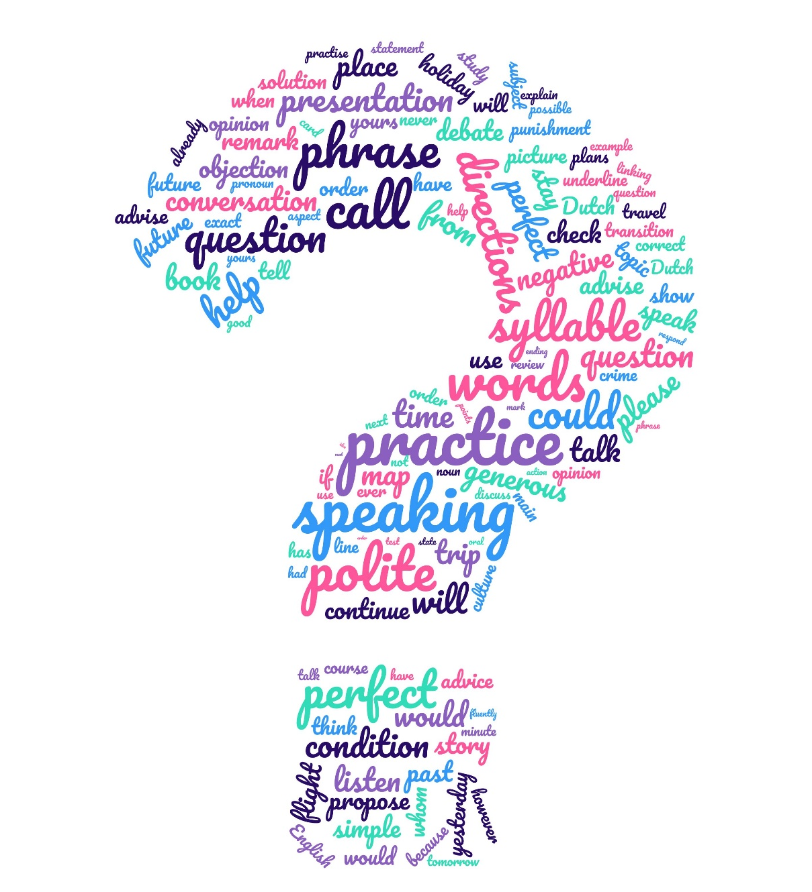
SPEAKING PRACTICE
In this part of the reader you will practice:
- Pronunciation
- Telling a story
- Reacting adequate
- Giving your opinion
- Describing object

A few British pronunciation rules

If you ask for English pronunciation rules, a lot of people will tell you there aren’t any. Well, that’s not exactly true, but there are more exceptions than rules. There are 52 sounds in the English pronunciation, which is pretty neat with only 26 letters!
The most straightforward rules concern the consonants, to give rules for the vowels is much more complicated.

Postvocalic ‘R’
At the end of words like ‘together’ and ‘bear’ you do not pronounce the ‘r’ like in American, you simply don’t pronounce the ‘r’.
Other cases like ‘bird’ and ‘stork’ are treated the same way, the ‘r’ is to be left out in pronunciation.

‘TH’ - phobia
A lot of people are having difficulties with pronouncing the ‘th’ sound. When you pronounce a word like ‘this’ and ‘the’ you must make sure the tip of your tongue is (almost) visible to the other speaker every time you pronounce the ‘th’ sound (your tongue has to be between your teeth when pronouncing the sound).

How to pronounce a ‘C’
A ‘C’ is normally pronounced as a /k/. It sounds like an /s/ if followed by ‘E’ ‘I’ or ‘Y’.
Example: ‘circus’. The first ‘C’ is followed by an ‘I’, so it sounds like an /s/. The second ‘C’ is followed by a ‘U’ so it sounds like a /k/. The same principle applies to ‘cycle’.
The word ‘accent’ follows the same rule. The first ‘C’ is followed by another ‘C’ so it sounds like a /k/. The second ‘C’ is followed by an ‘E’ so it sounds like an /s/.
E.g. call, cat, cool, copper, cut, class, cry, fact, music; success, accessory, occasion, occupy, cellar, place, since, cipher, circus, city, ceiling, cease, Caesar, cycle, cynic, mercy; success, accessory

‹ - ed›
/d/ after vowel, sonorant or lenis: loved, pleased, rubbed, called (but learned/learnt)
/t/ after ´t kofschip: fetched, hoped, passed
/id/ after /d/ en /t/: decided, ended, hinted, wanted
also certain participial adjectives: aged, learned, naked, ragged, rugged, wicked,
wretched
also in mostly in ‹ - edly, - edness›: fixedly, markedness

‹ - (e)s›
/z/ after vowel, sonorant or lenis: dogs, girls, boys, loves, rubs, calls, Tom's
busy, cousin, easy, music, present, season
/s/ after ‘t kofschip: cats, rocks, Jack's
/s/ in other combinations often written with c or ss: lacy, dress
/iz/ after s, z, etc.: buses, houses, bushes, matches, bridges, Rose's, chooses, fetches
but not after th: months, moths, clothes, paths

3 - consonant rule:
middle one in cluster of 3 consonants is usually silent
Christmas, postman, bustle, castle, thistle, postpone, handsome, Windsor, sandwich; also /t/ in often maar niet in soften, fasten, hasten, listen

‹ - gh( - )›
before ‹t› & final, usually silent: bought, caught, daughter, delight, eight, fight etc. etc.; bough, dough, high, plough, sigh, through, weigh
But /f/: cough, enough, laugh, rough, tough

‹ - mb, - mn›
and derivatives: ‹b› & ‹n› silent: bomb(er/ing), climb(er/ing), comb, dumb, lamb, numb(er)
(but number, timber, tumble: ‹b› not silent!); autumn (but autumnal), column, condemn(s/ed/ing), damn, hymn, solemn

‹h - ›
silent in a few words esp. derived from French: heir, honest, honour also often in unstressed syll.: prohi'bition (but pro'hibit!), exhibit, vehicle, Birmingham

Verb /z/ or noun/adj /s/
When a verb and a noun or adjective are (almost) the same, you pronounce the s in the verb like /z/, the c/s in the noun/adj like /s/
Verb: house, close, use, advise, exercise
Noun/adj: house, close, use, advice, exercise

I take it you already know …

I take it you already know
Of tough and bough and cough and dough?
Others may stumble but not you
On hiccough, thorough, slough and through.
Well done! And now you wish perhaps,
To learn of less familiar traps?
Beware of heard, a dreadful word
That looks like beard and sounds like bird.
And dead, it's said like bed, not bead -
for goodness' sake don't call it 'deed'!
Watch out for meat and great and threat
(they rhyme with suite and straight and debt).
A moth is not a moth in mother,
Nor both in bother, broth, or brother,
And here is not a match for there,
Nor dear and fear for bear and pear,
And then there's doze and rose and lose -
Just look them up - and goose and choose,
And cork and work and card and ward
And font and front and word and sword,
And do and go and thwart and cart -
Come, I've hardly made a start!
A dreadful language? Man alive!
I'd learned to speak it when I was five!
And yet to write it, the more I sigh,
I'll not learn how 'til the day I die.

Practise pronunciation

The Wind in the Willows
“It’s about your rowing, I suppose,” said the Rat, with an innocent air. "You're getting on fairly well, though you splash a good bit still.”
“O, pooh! boating!” interrupted the Toad, in great disgust. “I’ve given that up long ago. No, I’ve discovered the real thing, the only genuine occupation for a lifetime. I propose to devote the remainder of mine to it. Come with me, dear Ratty, and your friend also, and you shall see what you shall see!”
He led the way to the stable - yard and there, drawn out of the coach - house, they saw a gipsy caravan, shining with newness, painted a canary - yellow picked out with green, and red wheels.
“There you are!” cried the Toad, straddling and expanding himself. “There’s real life for you. The open road, the dusty highway. Here today, up and off to somewhere else tomorrow! Travel, change, interest, excitement! The whole world before you. And mind, this is the finest cart of its sort that was ever built. Come inside and look at the arrangements. Planned ‘em all myself, I did!”

Name student: | Selected words | Pronunciation underlined words | Grade
Text
“It’s about your rowing, I suppose,” said the Rat, with an innocent air. "You're getting on fairly well, though you splash a good bit still.”  “O, pooh! boating!” interrupted the Toad, in great disgust. “I’ve given that up long ago. No, I’ve discovered the real thing, the only genuine occupation for a lifetime. I propose to devote the remainder of mine to it. Come with me, dear Ratty, and your friend also, and you shall see what you shall see!”  He led the way to the stable - yard and there, drawn out of the coach - house, they saw a gipsy caravan, shining with newness, painted a canary - yellow picked out with green, and red wheels.  “There you are!” cried the Toad, straddling and expanding himself. “There’s real life for you. The open road, the dusty highway. Here today, up and off to somewhere else tomorrow! Travel, change, interest, excitement! The whole world before you. And mind, this is the finest cart of its sort that was ever built. Come inside and look at the arrangements. Planned ‘em all myself, I did!” | - rowing  - innocent  - though  - interrupted  - occupation  - remainder  - stable - yard  - coach - house  - gipsy  - straddling  - expanding  - the  - excitement  - cart  - arrangements |  | - □  - □  - □  - □  - □  - □  - □  - □  - □  - □  - □  - □  - □  - □  - □

The Marabar Caves
Except for the Marabar Caves - and they are twenty miles off - the city of Chandrapore presents nothing extraordinary. Edged rather than washed by the river Ganges, it trails for a couple of miles along the bank, scarcely distinguishable from the rubbish it deposits so freely. There are no bathing steps on the river front, as the Ganges happens not to be holy here; indeed there is no river front, and bazaars shut out the wide and shifting panorama of the stream. The streets are mean, the temples ineffective, and though a few fine houses exist they are hidden away in gardens or down alleys whose filth deters all but the invited guest. Chandrapore was never large or beautiful, but two hundred years ago it lay on the road between Upper India, then imperial, and the sea, and the fine houses date from that period. The zest for decoration stopped in the eighteenth century, nor was it ever democratic. In the bazaars there is no painting and scarcely any carving. The very wood seems made of mud, the inhabitants of mud moving. So abased, so monotonous is everything that meets the eye, that when the Ganges comes down it might be expected to wash the excrescence back into the soil. Houses do fall, people are drowned and left rotting, but the general outline of the town persists, swelling here, shrinking there, like some low but indestructible form of life.
From E.M. Forster, A Passage to India (Penguin)
Name student: | Selected words | Pronunciation underlined words | Grade
Text
Except for the Marabar Caves - and they are twenty miles off - the city of Chandrapore presents nothing extraordinary. Edged rather than washed by the river Ganges, it trails for a couple of miles along the bank, scarcely distinguishable from the rubbish it deposits so freely. There are no bathing steps on the river front, as the Ganges happens not to be holy here; indeed there is no river front, and bazaars shut out the wide and shifting panorama of the stream. The streets are mean, the temples ineffective, and though a few fine houses exist they are hidden away in gardens or down alleys whose filth deters all but the invited guest. Chandrapore was never large or beautiful, but two hundred years ago it lay on the road between Upper India, then imperial, and the sea, and the fine houses date from that period. The zest for decoration stopped in the eighteenth century, nor was it ever democratic. In the bazaars there is no painting and scarcely any carving. The very wood seems made of mud, the inhabitants of mud moving. So abased, so monotonous is everything that meets the eye, that when the Ganges comes down it might be expected to wash the excrescence back into the soil. Houses do fall, people are drowned and left rotting, but the general outline of the town persists, swelling here, shrinking there, like some low but indestructible form of life. | - miles  - extraordinary  - edged  - couple  - distinguishable  - deposits  - bathing  - ineffective  - though  - alleys  - deters  - zest  - scarcely  - abased  - monotonous  - excrescence  - indestructible | 16.  17. | - □  - □  - □  - □  - □  - □  - □  - □  - □  - □  - □  - □  - □  - □  - □  - □  - □

Practise describing objects

When describing objects, you should pay attention to:
- Shape
- Size
- Colour
- Material
- What it is used for
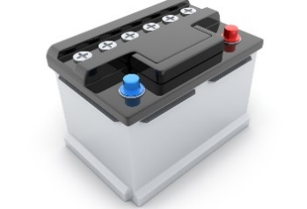 | 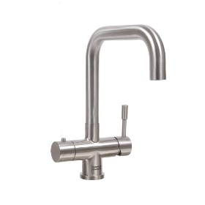 | 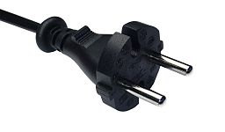 | 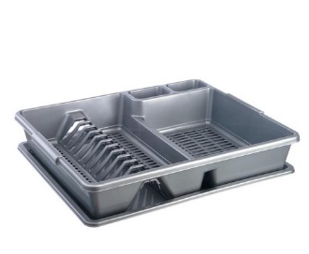
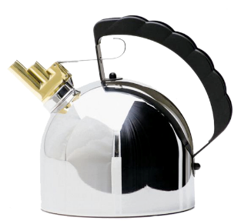 | 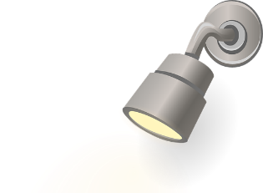 | 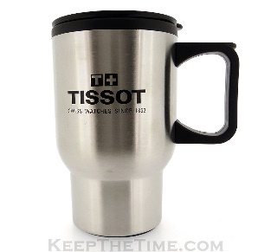 | 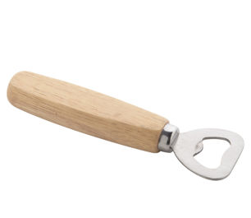
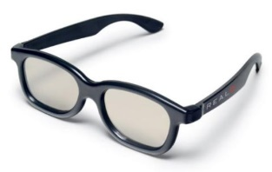 | 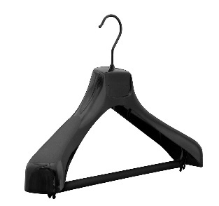 | 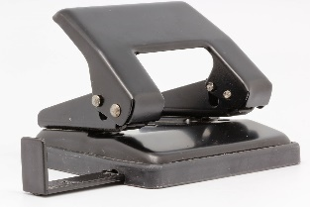 | 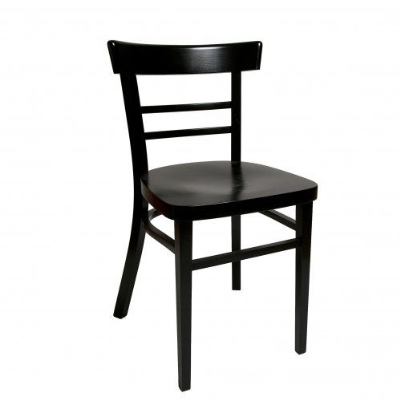
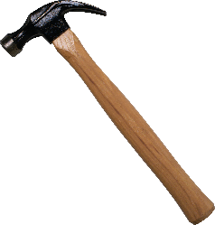 | 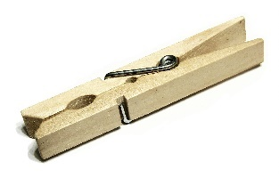 |  | 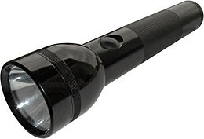
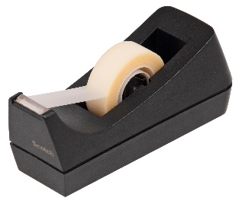 | 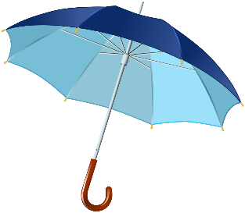 | 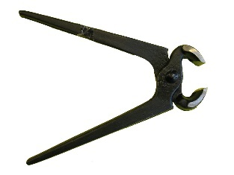 | 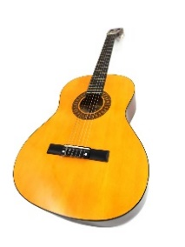
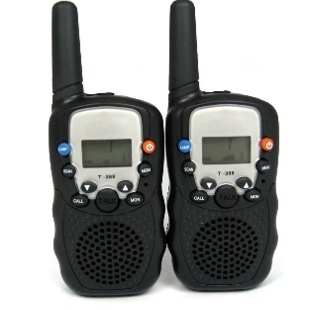 | 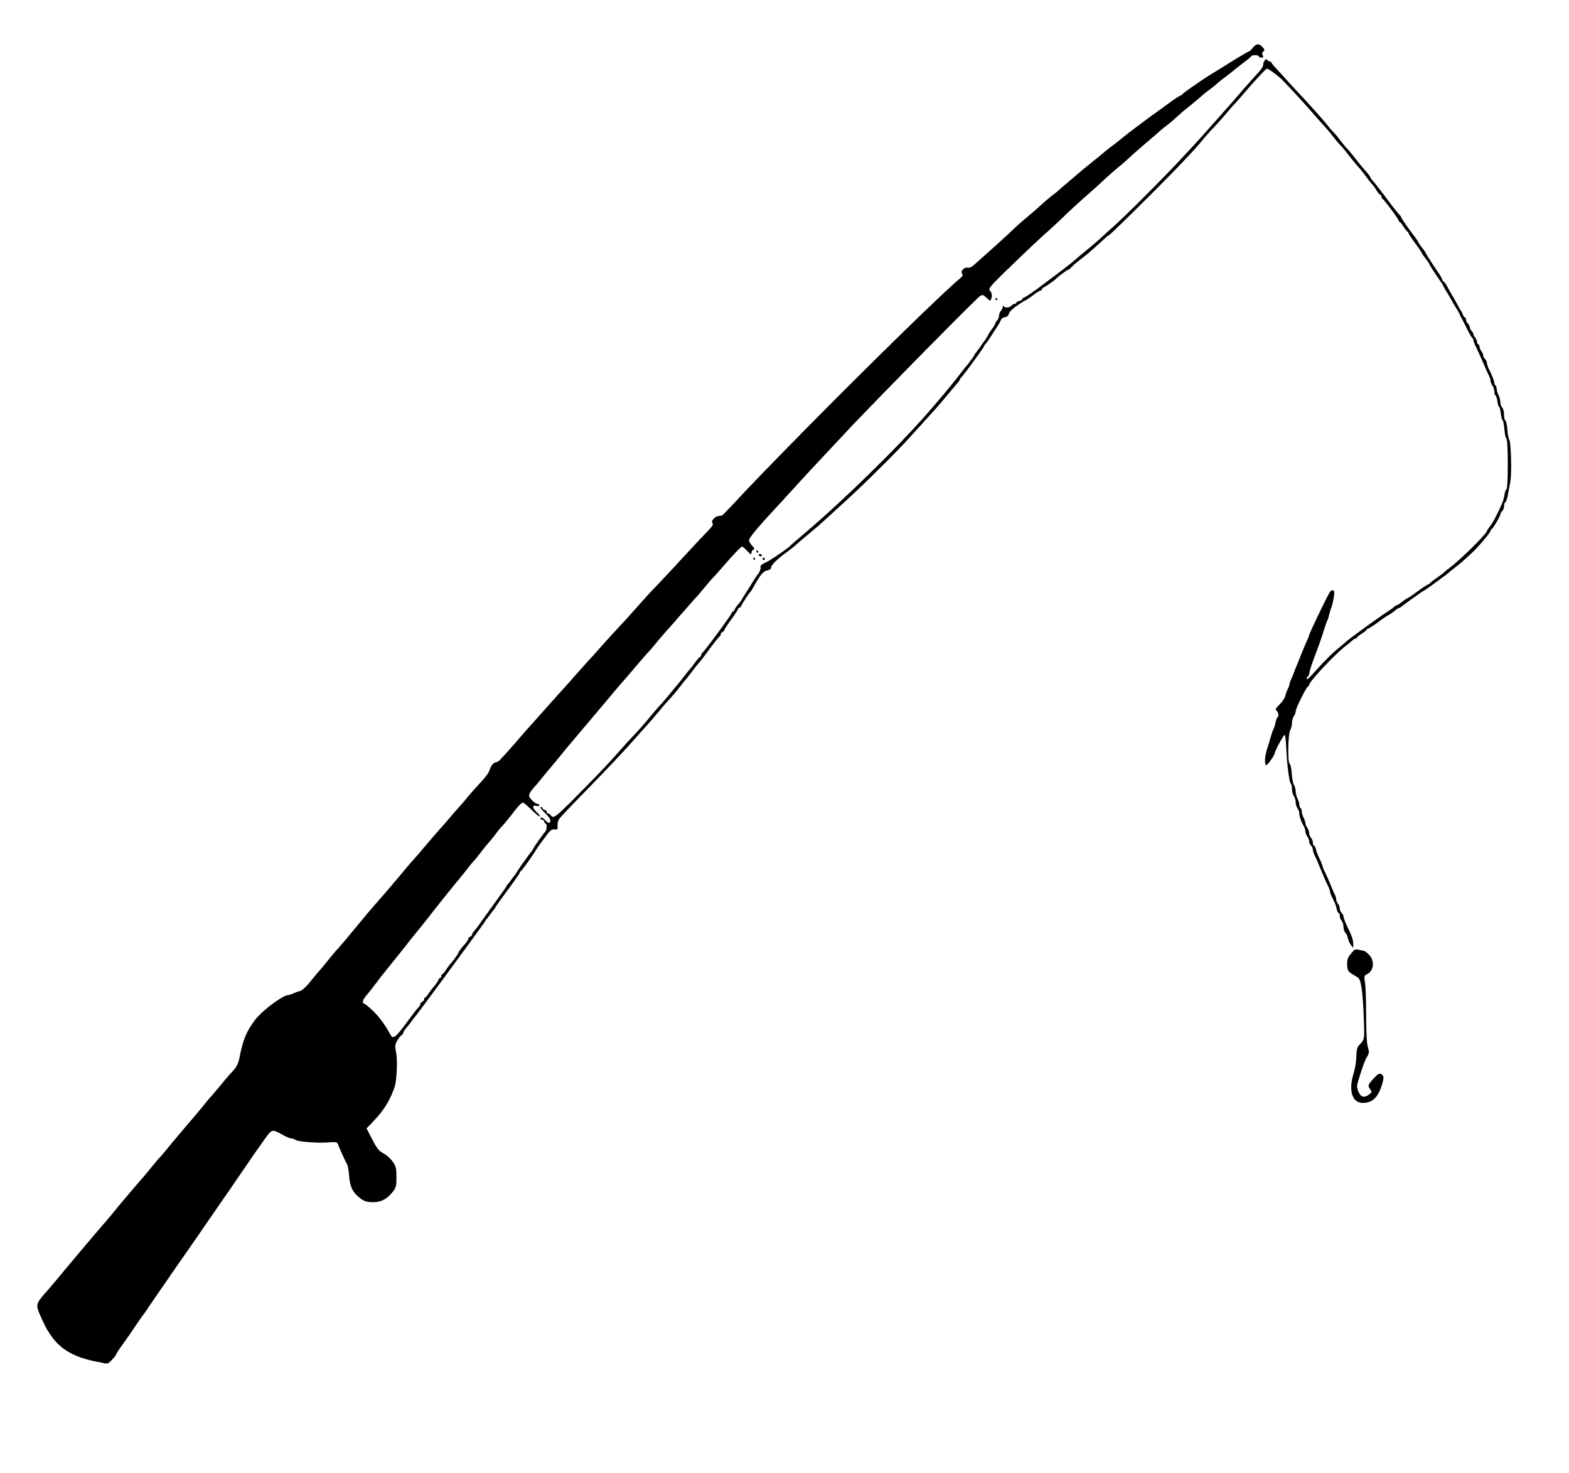 | 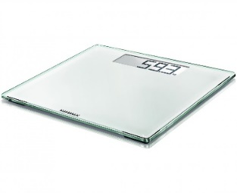 | 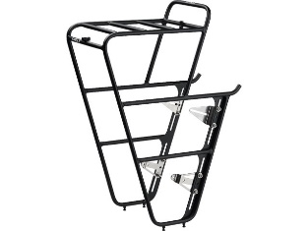
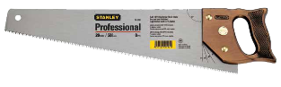 | 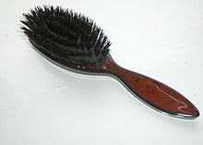 | 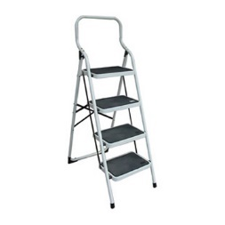 | 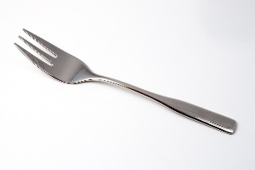
 | 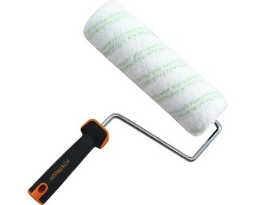 | 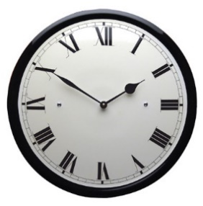 | 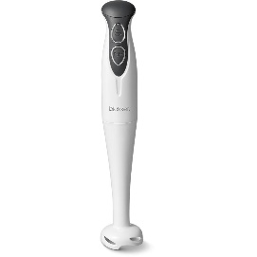
 | 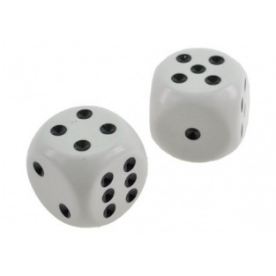 | 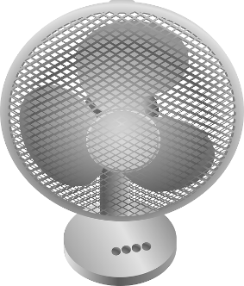
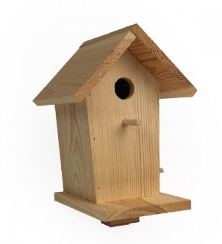 | 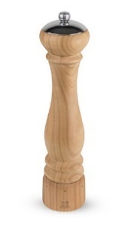 |  | 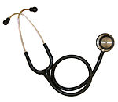

Telling a story with the help of a set of pictures

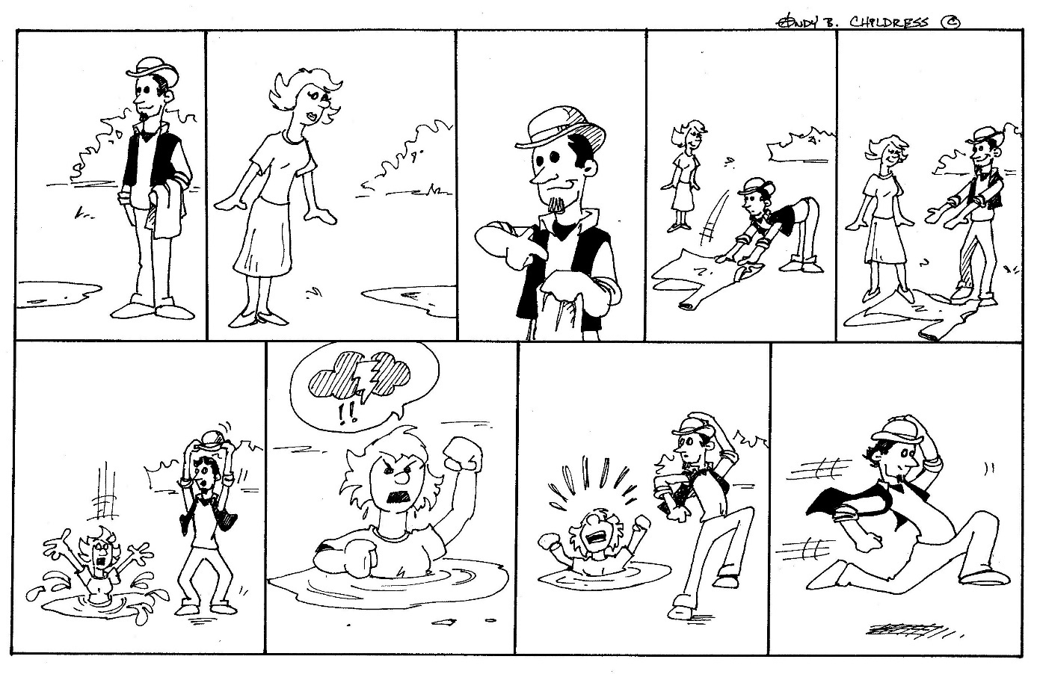
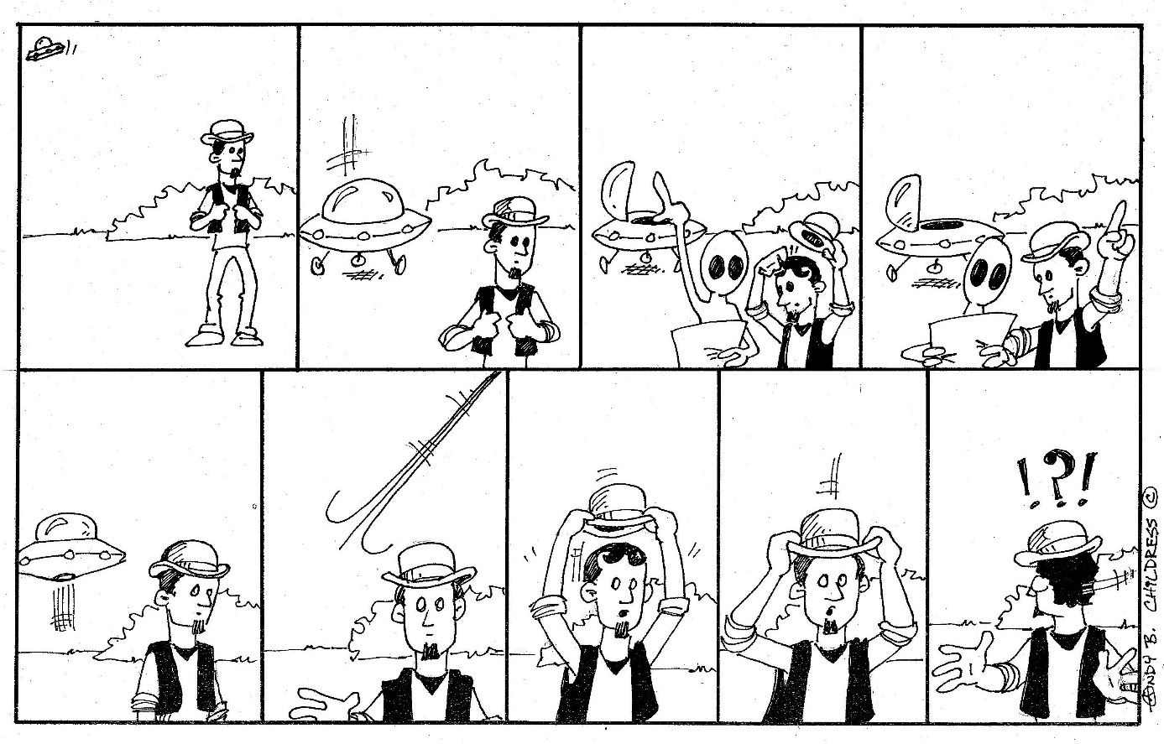
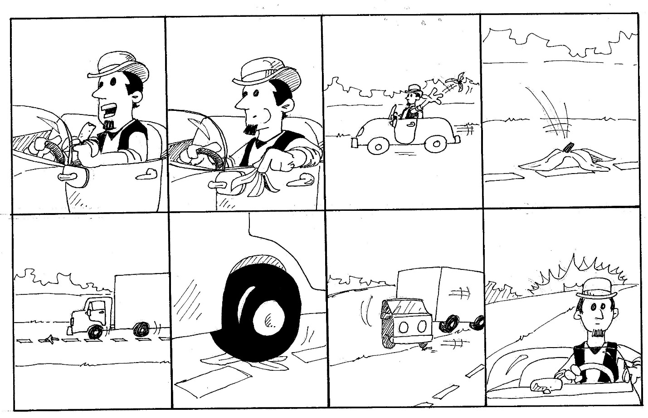
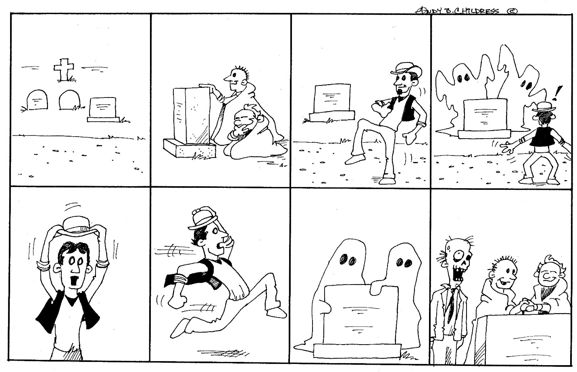

Having a conversation
Speech Card 1 a
Je loopt even een winkel binnen om wat te eten te halen. Elke dag in het hotel eten is veel te duur! Het is geen zelfbediening dus je moet alles aan de winkelbediende vragen.
Je wilt het volgende kopen: appels, brood, kaas, blikje drinken (zelf kiezen wat) en nog een reep chocolade. Bestel het netjes en beleefd!

Speech Card 2a
Eindelijk ben je in Londen aangekomen en nu moet je natuurlijk een hotelkamer boeken. Je stapt het Ritz Hotel binnen en je vraagt of er een kamer vrij is. Je wilt graag een tweepersoonskamer (hoewel je dus alleen bent..) met bad en wc.

Speech Card 3a
Je mobieltje is gejat! Je ouders zijn woest (het is niet de eerste keer) dus je moet naar de politie om aangifte te doen. Je mobieltje is gisteren, op school, gejat.
Je moet je naam, adres, leeftijd en nationaliteit vertellen en ook waar en wanneer je mobieltje gejat is.

Speech Card 4a
Je hebt lekker een uurtje in de pub (= kroeg) gezeten en je hebt net de rekening betaald en je wilde ook een tip geven. Je moest 13 euro betalen, je had gezegd er 15 van te maken (2 euro fooi dus) en je moet dus nog 5 euro terugkrijgen. De ober/serveerster loopt echter gewoon weg. Je krijgt helemaal niets terug! Dat pik je niet!
Spreek de serveerster/ober BELEEFD aan en vraag om je geld terug.

Speech Card 5a
Je bent een verkoper van tweede - hands auto’s. Een vreselijk slechte auto staat al maanden in je showroom. Nu komt er een niet al te slim uitziende klant je showroom binnen die uitgerekend naar deze auto vraagt.
VERKOOP DIE AUTO en probeer er zo veel mogelijk geld voor te krijgen!

Speech Card 1b
Je bent verkoper/verkoopster in een winkel. Het is geen zelfbediening dus je klanten moeten alles aan jou vragen. Er komt een klant binnen.
Je geeft helemaal NIETS als die klant niet met een vriendelijke groet begint (hello, good morning, etc). Verder geef je alleen wat er besteld wordt als er PLEASE bij gezegd wordt! Je verkoopt trouwens geen alcohol.

Speech Card 2b
Je bent receptionist(e) in het Ritz Hotel in Londen. Er komt iemand binnen die een tweepersoonskamer besteld maar hij/zij is helemaal alleen… Je mag die persoon ABSOLUUT geen tweepersoonskamer geven. Natuurlijk moet je zo vriendelijk mogelijk weigeren en je biedt hem/haar daarom een mooie kamer aan met douche en TV.

Speech Card 3b
Je bent een politieagent(e) en iemand komt melden dat zijn/haar mobieltje is gejat. Jij moet dus alle gegevens van die persoon weten, dus je vraagt naar de naam, het adres, de leeftijd en de nationaliteit. Ook wil je weten wanneer en waar het mobieltje is gestolen.

Speech Card 4b
Je bent echt doodop! Je hebt de hele dag gewerkt (je bent ober/serveerster) en eigenlijk had je een uur geleden al naar huis gemogen. Nu is het eindelijk zo ver! Je wilt nu meteen naar huis en je rekent snel af met de laatste klant.. komt die achter je aan en begint te zeuren. DAAR HEB JE DUS HELEMAAL GEEN ZIN IN! Blijf wel beleefd!

Speech Card 5b
Je wilt een auto kopen maar ja, geen geld! Dus dan maar een tweedehands auto. Je gaat een showroom binnen waar al een hele tijd een auto staat. Hij is niet best, dus die kan je goedkoop kopen. De verkoper ziet er niet al te slim uit, dus dat moet lukken. Probeer er zo weinig mogelijk voor te betalen (dus kraak hem aan alle kanten af: oud, roestig, ouderwets, etc)

Giving your opinion

Give your opinion on the subjects below. Use the aspects given. Talk at least 1 minute.
- There are a lot of speed ramps In Holland. People seriously differ in opinion about these things. Give your opinion. Use the aspects of:
Deze foto van Onbekende auteur is gelicentieerd onder CC BY-SA
  - veiligheid (van wie?)
  - schade voor auto’s
  - irritant

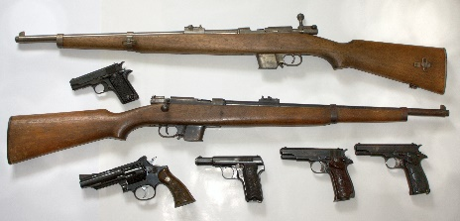
- A lot of people carry guns In America. They often do this for their own safety. Give your opinion on this. Think of:
  - hoeveelheid geweld
  - de rol van de politie
  - gevaren (voor wie?)

- Some people argue that animals should enjoy certain rights in the way that human beings. What do you think about the concept of animal rights?
  - testen voor medicijnen
  - dieren minder belangrijk dan mensen
  - bescherming voor uitsterven

- Some people blame foreigners for things like crime and unemployment. Give your opinion. Don’t forget to mention why most of them are here.
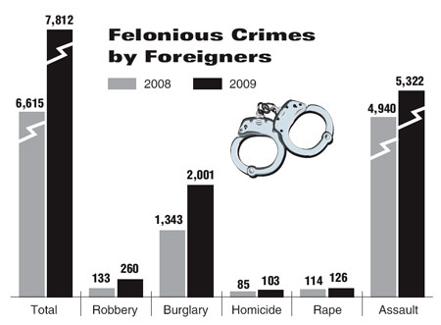
  - mensenrechten
  - goedkope arbeidskrachten
  - cultuurproblemen
  - inburgeringsproblematiek

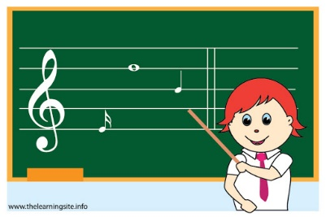
- The government wants to take the subject of music from the school curriculum because it is too expensive. Say what you think of this.
  - Culturele waarde
  - Zorgt voor afwisseling op school
  - Belangrijke uitlaatklep voor emoties

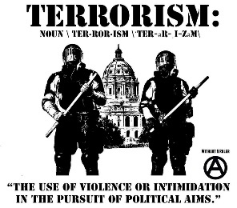
- Terrorism has become a topical subject. Discuss what you think causes it and what could be done to prevent it.
  - Strenge controle
  - Extreem godsdienstige instelling
  - Oorlogen uit het verleden

- Crime and punishment. It is often said that punishments nowadays are not severe enough. Explain the situation in your country and give your opinion. Use the following aspects:
Deze foto van Onbekende auteur is gelicentieerd onder CC BY-NC
  - Verschil jeugd en volwassenen
  - Verschillende soorten misdaad
  - Gevangenisstraf - taakstraf

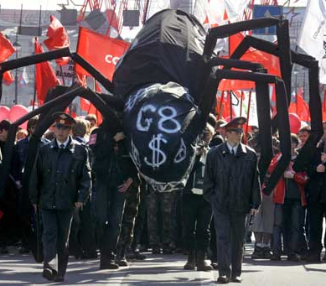
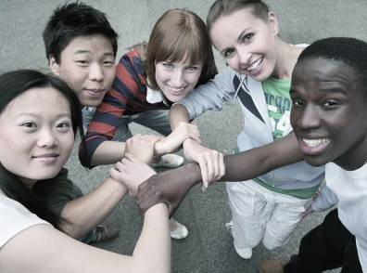
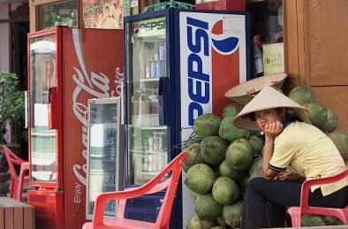
Word Bank
- driving forces: international trade, investment, information technology
- rapid increase in economic/ technological exchange, free trade, free movement of goods/resources, multinational corporations, compete on a global scale, competitive prices, economic boom, greater choice for consumers, lower costs for companies
- create employment, grow prosperous, share information worldwide, new demand on education/training, adopt new values of democracy/human rights, promote goodwill/ understanding among different nations
- new form of colonisation, profits are taken out of a country, local industries/businesses disappear, unemployment is on the rise, exploitation of workers, sweatshops, increasing inequalities
- development of uniform /western lifestyle, disappearing local culture/ cuisine/language, decrease in cultural diversity
Compare and contrast these pictures. In your description, answer the following questions:
- What aspects of globalization can you recognize?
- What are the driving forces of globalization?
- What fields of life are mostly affected by globalization?
- How is local economy/culture/trade/ politics/environment/tourism/food changing?
- How has your country been affected?
- What do you gain from globalization?
- What do you lose?
- Why do many people support globalization? Who are they?
- Why do many people oppose it? Who are they?
- How does globalization affect the English language?
Picture-Based Discussion

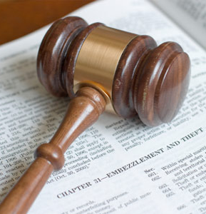
Compare and contrast these two pictures. In your description, answer the following questions:
- What is the relationship between the pictures?
- What crime do you think the man behind the bars has committed?
- What crime do you find the most/ least serious? Why?
- What makes people criminals (social background, education, personality, etc)?
- What crimes are the most common in your country?
- What role do detectives/the police/ lawyers/law courts play in criminal investigation?
- How does jurisdiction work in your country?
- Do you approve of capital punishment? Why/why not?
- How can people with criminal records adjust to life after they are released?
Word Bank
- commit a crime: pickpocketing, theft, shoplifting, burglary, robbery, mugging, money laundering, embezzlement, blackmail, white collar/organized/war crime, hit and run accident, drink-driving, manslaughter, homicide, murder, assassination, drug trafficking, smuggling, kidnapping, hijacking, vandalism, hooliganism, sexual assault, juvenile delinquency, arson
- break the law, get away with a crime, escape, hide from the police, establish/ prove an alibi, give oneself up
- investigate, collect evidence, arrest, accuse sb of a crime, witness a crime, eye-witness, take legal action/a case to court, charge sb with sth, come on for trial, court room, counsel for the defence, jury, judge, lawyer, plead guilty, return a verdict, sentence sb to 5 years in prison, receive a life sentence/ capital punishment/death penalty
- be on probation, get pardon/amnesty, serve one’s time, struggle to find a job/housing, recidivist/ habitual criminal
Picture-Based Discussion

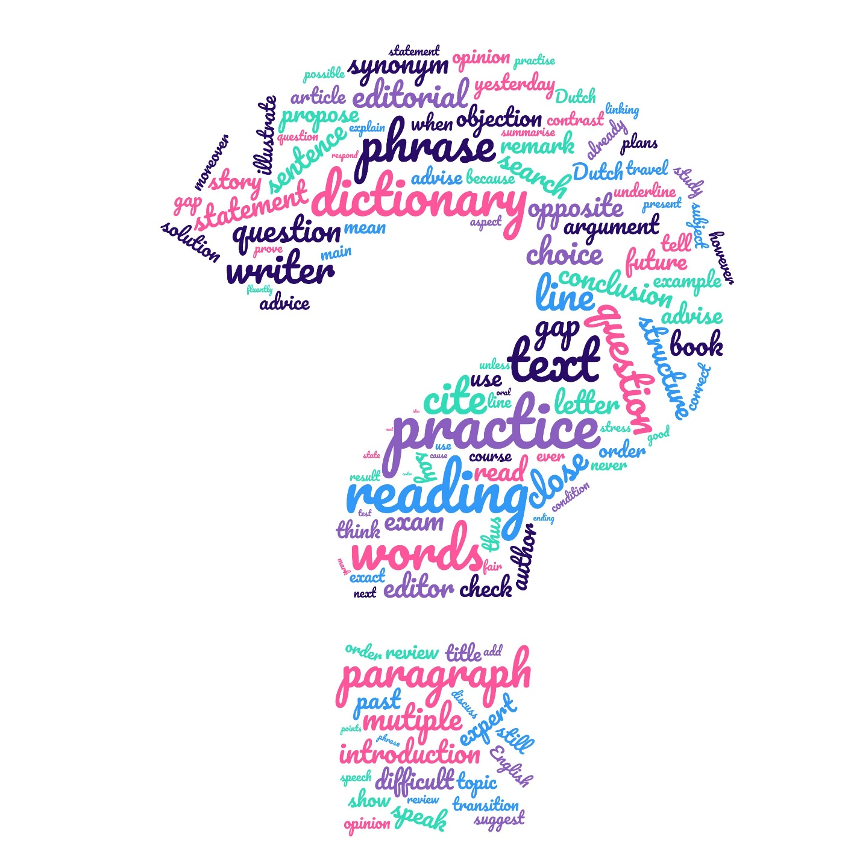
LISTENING PRACTICE
In this part of the reader you will practice:
- Listening strategies
- Checking your answers with the written text

How to prepare for a Cito Listening test:

Before the test
Some tips are so obvious, they hardly need mentioning, but to make sure you are aware of them, we will make sure by writing them down anyway:
- Listen to English on TV, Streaming websites or Internet. To make sure you learn to necessary words, choose
  - documentaries
  - Informative programs
  - Podcasts
  - TED-Talks
This way you will get used to the language, the speed and accents native speakers use.
- You may practise with or without ENGLISH subtitles, not Dutch.
- Build up your vocabulary. It may sound strange when you want to practise listening, but the best way to do this is by reading. It can be anything that you find interesting, provided it is at the right level. Novels, non-fiction, the news, informative websites, etc.

During the test
What makes Cito listening test more difficult for some students than reading, is that you cannot go back and listen repeatedly all the time. You simply will not have the time to do that. So here are some do’s and don’ts:
- Listen carefully to the introduction. It contains useful information.
- Read the question and the answers.
- Stop reading when the speaker starts. You cannot read and focus on listening at the same time, besides, the answer you need is often at the beginning.
- Don’t translate into your own language. Again, this takes away your focus from the speaker while your brain is occupied with translating. You can often deduct the meaning of the words from the context.
- Listen to the whole fragment before choosing your answer.
- Remember that (part of) the answer is often said more than once. Don’t get distracted.
- Sometimes it helps to close your eyes while listening. This help
- Make sure the complete answer is correct. Sometimes only part of it is, the other part is not mentioned or not in accordance with the text.
- Pay attention to the linking words. One of the answers is sometimes the opposite of what is said. You miss that if you don’t pay attention to the linking words.

Text listening test
Do the test first, then read the text and mark where you can find the right answers. Make sure you see what words/phrases helped to find the right answers.

Audiodeel

Eerste deel: Packaging

Inleiding
Presenter: The packaging industry that makes the boxes and cans and wrapping that we encounter everyday of our lives is frequently under pressure from politicians, from the media, from consumers who look at their waste bins brimming with packets even if they're ready for recycling. So what are the packaging people doing about it? That's what this programme is all about.
- Presenter: Robert Opie knows more about brands, packaging and advertising than maybe anybody else.
Robert Opie: Weil, hopefully the history certainly because we go back to Victorian times, which is the kind of spring board of this new consumer society.
Presenter: Now, we didn't really need packaging to generalise wildly, very much until mass production came along and people started crowding into cities and bought things that were sent in from a long way.
Robert Opie: And of course the thing that really activated the need for individual packaging was that the naughty grocer at this time was adding spurious substances and adulterating the food, making added weight and therefore making added profit. And the manufacturers soon realised that the way to get round this was to package in individual quantities that the consumer wanted and therefore have products that were untouched by other people's hands.
- Presenter: This is a most extraordinary place in West London: it's the Museum of Brands Packaging and Advertising. Case after case here absolutely crammed with things. There's a whole case of washing powder, and then breakfast cereals of course. And then 'After Eight' celebrating of course a great rise of a middle class who had dinners and wanted to finish off the dinner in this elegant way. This is all about packaging. This is actually a history of democratisation of things isn't it?
Robert Opie: Well, you're absolutely right. You know, I think that in fact branded packaging has been a leveliser in our society because now everybody essentially can afford the same sauce as the prime minister is putting on his chips.
Presenter: Robert Opie founder of the Museum of Brands, Packaging and Advertising.

3 Presenter: Helene Roberts at the Benson Group in Leicestershire.
Helene Roberts: If you look at a total carbon foot print of products, what you'll find on average is that the packaging is probably representing just under ten per cent of its make-up. So that ten per cent becomes very important as it starts to protect the carbon that was used in order to get that product, whether it was grown or reared or manufactured, to the store.
Presenter: So ten per cent is a fairly hefty amount, but, if you reduce it -
Helene Roberts: So if you can reduce that ten per cent, absolutely, but the life of any product and the quality of that product throughout its shelf life, is really key that you're using packaging to enable that, to be bought by the consumer and used by them in the right way, not to straight away engender more waste.
Presenter: A delicate balance.
Helene Roberts: It is a delicate balance.
- Presenter: The overall thing is still that waste is still an enormous problem and packaging has a lot to do with that problem.
Helene Roberts: Packaging is part of that because it's part of the product that we are buying so the overall waste that we've got to manage as consumers, as, and as a nation is how do we prevent waste there in the first place? And we should be doing that in the most effective way whether we feel guilty about it or not. As soon as that goes out of kilter with how people feel about it, you know, a number of years ago when people felt that was terribly over-packaged, a lot has been done. That's not by the industry in its own right, that's been about collaboratively, whether it's the industry, whether it's the government, whether it's the actual manufacturers, to start thinking about how they make their brand decisions, it is all part of the same value chain.
- Presenter: John Revess, director of sustainability at the big can makers, Rexam.
John Revess: Every home in the UK, almost every home has a recycling bin provided by the local authority.
Presenter: And then if you use the bin the can is actually recycled, really is it? Because one is a bit suspicious when the bins are all taken away and all the recycling stuff is all muddled up again.
John Revess: In the case of cans which are metal it's the most valuable part of the rubbish. And in fact it's the recycling of that metal that helps offset the whole costs of running the waste collection system. So, it's an absolute guarantee.
- Presenter: Grant Montague works in the London office of an international firm called Perception Research Services. For more than forty years it's been examining how consumers react to the products they may or may not buy. Packaging has a lot to do with it.

Grant Montague: If you ask someone to describe Coca Cola, they don't necessarily come back to you and talk about a brown fizzy drink. The connotations are around the pack. So they might mention about the iconic bottle, the red can. So the pack becomes a core element of how you view the product. Typically when someone is conducting a shopping exercise they're probably in the store for twenty to twenty-five minutes. So the consumer is being confronted by thousands of products. They are scanning. They are using cues very quickly to identify the one that's for them. So it is around about ten seconds and you're off.
- Grant Montague: Consumers will say that packaging isn't important to them. Whereas we know it's extremely important, both in terms of providing information but also in their confidence in the product itself. If consumers do not think the packaging is robust enough and therefore might not be able to get the products home or keep the product within the home their consideration may wane. Even if they say to us that there's sometimes too much packaging, it's not necessarily the case because the one thing they don't want to do is have an unprotected product.
Presenter: Grant Montague Vice President Europe at Perception Research Services.
- Presenter: So that double or triple wrapping that you get guilty about when you're unwrapping the product at home, you actually go along with that until you actually start thinking about it when you get it home. Is that the sort of way things go?
Grant Montague: A lot of the time, yes. I mean, consumers are stimulated by the packs on shelf. I mean it's a marketing vehicle. In getting more rational around about the pack itself and the amount of packaging that there is, that tends to happen later on in the equation or when you ask consumers to think about it more deeply.
- Presenter: Dick Searle has been involved in the industry for years. He's seen decades of changing packs and changing attitudes to them. What is packaging for?
Dick Searle: Packaging only exists because people buy products. It's as simple as that.
Presenter: It's as simple as that except that everything is now over-packaged and everybody tells you that, don't they?
Dick Searle: Yes, they do and of course I couldn't sit here and say there is absolutely no overpackaging. I'm sure there are some things that are. But it's also a supply chain which is absolutely brutal in terms of its competitiveness. Very few people pay more for their packaging than they need so the absolute minimum packaging is needed to do the job, even if you buy something which looks just like a tray with a bit of cling film, frequently even for the basic products that's a seven-layer film which has all kinds of properties in order to preserve the product.
- Presenter: This is the Hampstead Marks & Spencer food store and with me is Simon Oxley, a leading M&S packaging technologist. Why not make edible packaging that you boil and sterilise before the eating process? That would be the ideal solution to food packaging, wouldn't it?
Simon Oxley: Umm, yeah, edible packaging is an interesting one because you can make that. If you're going to eat the packaging you want to make sure that it's clean. So then if you think you well I'm going to boil it, well actually the energy that's gone into that, is that going to affect the taste or the product and also what about the carbon footprint of the method you've used to sterilise it?
Presenter: Yeah, but you might have some packaging that could make perfectly good shepherd's pie for example and you'd cook it anyway so you're not using extra stuff just to make sure it's clean, just an ideal I give it to you for nothing.
Simon Oxley: Thank you, Peter, there's a job in my team anytime, yeah.
- Presenter: And more thoughts about the impact of packaging from Jane Bickerstaffe of tncpen, the industry wide research organisation set up in 1975.
Jane Bickerstaffe: When we looked at the food that typically feeds a person for a week and looked at the energy that it takes to grow that food, to grow the field of wheat, to make the flour, to make the loaf of bread, then looked at the energy to transport it through the supply chain, to package it, to heat and light the shops and then in people's homes how they store it. And then you can get an idea of where you can make improvements to these systems.
Presenter: And the proportion of energy expended on packaging?
Jane Bickerstaffe: Ten percent typically. With something like meat where the carbon foot print of keeping a cow is huge then the packaging percent goes down to about three percent. If it's something with er, potatoes, with a low carbon footprint to grow, then the packaging is a higher proportion.

Tweede deel: Has Technology Changed Us?

Inleiding
Presenter: Hello, and welcome to 'A History of Ideas', the series that tells the story of ideas through some of the bigger questions we ask ourselves. These questions don't have one but many answers, and they've engaged and perplexed people across history, in different cultures and in different places and in different areas of thought. And this week's question is 'How has technology changed us?'
- Presenter: Matt Pope, the idea about the technologies such as the internet, people say it's rewiring our brains and so on. What plausibility do you give to that?
Matt Pope: I'm not a cognitive scientist. I wouldn't be able to say what's actually happening in the brain. I certainly think if networks are the basis for human society and where human culture exists, we only have to look over, say, the last maybe eighty thousand years at the spread of modernity, our own behaviour of, of our own species as that spread around the planet or we can see this spread and replace not only the cultures that were there previously, but in the case of species like the Neanderthals we see the replacement of Neanderthals. And that's all down to networks. Developing a global network think is phenomenal because what you're actually looking at doing, fundamentally not rewiring our brain but rewiring the planet.
- Tom Chatfield: I used to pore over my road atlas before a long journey, memorising the route, I used to read road signs and pull over when saw something interesting. I used to act, in short, like an independent human being. These days I sometimes feel like a slave to the satnav, though I don't get lost as much. So, is my relationship with tech a collaboration or a takeover? Are rather once important mental functions rotting through neglect? We're not the first generation to worry about this kind of thing. In Plato's Phaedrus one of the characters in it has a surprisingly similar tech complaint to mine: he's worried about the invention of writing. 'This discovery of yours,' he says, 'will create forgetfulness in the learners' souls, because they will not use their memories. They will be hearers of many things and will have learned nothing'.
- Tom Chatfield: Some people have argued that there's a sort of dangerous self-fulfilling prophesy in allowing machines to do too much for us, in that automation treats us 1-, a bit like idiots or children.
Presenter: Tom Standage is the digital editor of The Economist.
Tom Standage: No, I'm not quite sure. I mean, if l, if my car could drive itself I'd be able to, you know, appreciate the surroundings more easily and I'd be able to read a book or do whatever I wanted to do. It, erm, you could say the car is infantilising me, but you could also say, well, why did I ever really have to drive it in the first place? I think driving cars is one of those things that will come to appear morally unacceptable in twenty years' time. We'll say, God, we can't believe we put people in charge of these one-ton pieces of metal, and, you know, they were, used to drive around killing each other and we used to tolerate this.
- Female reader: Francis Bacon was an English statesman, scientist and philosopher in the sixteenth and seventeenth centuries and a pivotal figure during the scientific revolution of Europe, After his political career ended in a corruption scandal he devoted himself to scientific enquiry.
Justin Champion: Bacon had a profound confidence in the potential of human ingenuity to make society better. He was also very concerned by the ethical ambiguities of progress. He recognised that the figure of the human technological innovator posed a problem. Bacon quite deliberately announced an ambitious new scientific project that challenged the dominant Aristotelian model of natural philosophy. For Bacon, modern science was to be active, experimental and based on observation of the natural world.
- Justin Champion: I went to Sheffield to meet professor Richard Jones. He works in nanotechnology.
Richard Jones: A scientist who does something that is recognised by other scientists as just being really cool, they get a lot of kudos from that, and that's important to people. We look at some of the discoveries of the twentieth century, nuclear weapons and such like. They were done with a full knowledge of how destructive they were going to be. What motivated the scientists to make nuclear weapons? Partly a feeling of that's what they ought to do, that's what they were being asked to do by their society but, frankly, I'd be surprised if some of those scientists didn't think, well, actually, these are technically sweet problems for all their horrible outcome.
- Richard Jones: The most important people of the twentieth century were Haber and Bosch. They invented this process for fixing nitrogen. They did that because that was the key to producing explosives for the First World War, but the side effect it had, was that it made it possible to have artificial fertilisers, so the entire growth of population that we saw in the twentieth century can be put down to that invention. The population of the earth as it currently stands, probably about half of them would starve if it was not for the Haber Bosch process. So, we've done the first bit of it, found a world-changing technology and we haven't actually managed to sort out what the, er, technological fix that will get us out of the problem will be.
- Female reader: Hippocrates was a Creek physician in the fifth and fourth centuries BC, and is thought of as the father of Western medicine and medical ethics. His name is remembered in the Hippocratic oath, a set of rules which set high ethical standards for the practice of medicine.
Gabriel Weston: Now, I didn't take the Hippocratic oath when I graduated from medical school, but I still feel there's a real ethical responsibility inherent in what I do in the operating theatre. People on the receiving end of surgery, when they're anaesthetised and everything is sterilised and safe, don't really realise quite what an extraordinary thing it is to cut into a human being. One of the key tenets of the Hippocratic oath is really that of doing no harm. As we're able to do more and more with technological advances in surgery, we're going to need to think even more carefully about whether what we're doing benefits our patients or puts them at unnecessary risk. 19 David Pearce: If you think back why is there so much suffering in the world today, essentially it's because mother nature didn't design us to be happy. Basically to be discontented, depressed, anxious, frustrated, resentful, jealous, a, a lot of the time actually helped our genes leave more copies of themselves. Now, take something like empathy — for evolutionary reasons most of us are pretty selfish. In future it will be possible to choose how naturally empathetic either, er, you or your offspring are and it will be possible for us to be far more loving and empathetic than is technically feasible now.
20 Clive Gamble: In human evolution you never get something for nothing.
Matt Pope: I've come to talk to professor Clive Gamble of Southampton University.
Clive Gamble: If you're going for a large brain it has to trade off against one of the other organs in the body. The only part of the, er, soft-tissue anatomy that you can really trade against is actually the intestine, but by shrinking your intestine, you're cutting down on the processing part of the intestine to extract energy from the food that you eat. So you start to require higher quality foods to make up for that shortfall. Bigger brains equals higher food but also smaller stomachs which require higher foods again, and so technology is one of the ways in which you start to balance that very basic equation that is, that faced our ancestors.
Einde van het audiodeel

Videodeel

Eerste deel: Lord Coe

Inleiding
My guest today is Sebastian Coe, former British Olympic Champion. He set 12 world records during his athletics career on the track and went on to hold many roles in various sporting organisations as well as a stint for 5 years as a conservative MP. Well now, he wants to become the president of the International Association of Athletics Federations, the IAAF. What has he done so far and what more can he do to help clean up sport.
- Presenter: Just looking at sport as a whole really, you need to integrate it don't you, into everybody's world? And when you're talking about young people in particular and you look at them all over the world, the major preoccupation for so many of them is: I want a good education and I want to get a job. We know that in so many countries there's a very high rate of unemployment amongst young people.
Lord Coe: Yes, but that... that is not a proposition that is mutually exclusive from sport. Actually there are young people in many environments that are surviving the day but I've seen the work of our programmes in parts of the world that are particularly challenged, where sport is a saviour.
Presenter: In Mozambique they set up small, medium companies to produce sportswear and footballs which provided employment by allowing people to... to make and sell these things.
Lord Coe: This is far more— Presenter: You said also —
Lord Coe: than trying to find, to find the next David Beckham — Presenter: Sure
Lord Coe: or the next Roger Federer.
- Lord Coe: Sport actually delivers in the most extraordinary way and gets closer to many challenges than... than orthodox politicians do. And, and let me give you a very good example. In 2003, when I was campaigning for... to bring the games to London I went to the opening ceremony of the Afro-Asian games. It took until 2003 to get it across the line, we were in Hyderabad. In the margins of the opening ceremony two sets of foreign, eh, foreign officials from India and Pakistan came together to discuss how they could reduce some of the tensions between the two nations. They were almost on an nuclear footing. And the first thing they thought about and did was to re-implement the test match series. So the, the, the, sport actually is not just mirroring society, it's actually often setting its trends.
- Presenter: Gabriel Dollé, director of the IAAF 's anti-doping department has left his post after being interviewed by the ethics committee of the IAAF. Do you think he could be reinstated after the investigation is carried out? What do you think?
Lord Coe: Well, first of all, this, these are allegations and they are serious allegations. Nobody is remotely shying away from that. We have an ethics committee, which I actually, I helped create over a year ago. And it is that ethics committee that is now going to explore those allegations and they are across a whole range of issues, they are not just simply about doping. We must let that ethics committee do its work and that is important and they are of course working in conjunction with the world anti-doping agency and even the international Olympic committee.

Tweede deel: Hidden Dangers
- Dr Suzannah Lipscomb: One thing that particularly indicated both good taste and status was wallpaper. A particularly brilliant green known as 'Scheele's green' was all the rage. The magic ingredient that was giving the wallpaper its rich green hue was arsenic. Modern science can prove that Victorian wallpaper contained arsenic but this danger wasn't fully understood at the time. To confuse matters further, the symptoms of arsenic poisoning were very similar to cholera which had been rampant in Britain in living memory.

Dr Suzy Lishman: The immediate effects would be of pain, swelling of the oesophagus, very dry throat and difficulty in swallowing and then what's described as 'agonising abdominal pains' as the whole digestive tract is affected by the arsenic.
- Dr Suzannah Lipscomb: Some doctors and newspapers called on the British government to ban the poisonous paper. But others were quick to belittle the claims of the killer wallpaper. Some manufacturers even offered to eat it to prove how safe it was. One of Britain's most celebrated wallpaper designers was William Morris, a leading light of the arts and crafts movement. He was also one of the fiercest critics of the heartless industrialists of this period. But what is not well known about this champion of handicraft is that he was a director of the biggest arsenic producing mine in the world: Devon Great Consoles.
Prof Andy Meharg: William Morris was making most of his money from arsenic.
Dr Suzannah Lipscomb: That's quite a surprise, isn't it? Because of course we associate William Morris as being, you know, this leader of the arts and crafts movement, as someone who's, you know, going back to basics, going back to natural things.
- Dr Suzannah Lipscomb: Women were expected not only to create the perfect home. The lady of the house had to measure up as well. Lurking in many beautifying products were harmful toxins. Part of being the ideal Victorian woman was looking just right. Whatever your physique, one of these came in handy. In fact this was essential.
Dr Kate Williams: Corsets kept everything under control and they meant self-reserve and that was vital to the Victorian woman because the opposite was just excess and freedom and flesh flying everywhere and once you do that, well, the world might fall down.

Derde deel: Youth Parliament

Inleiding
Poverty is something you normally associate with people, families who are heavily reliant on the state. However, in fact, for the first time in British history, the majority of families who live in poverty are in fact from working households. Five point three million workers are earning less than the living wage of seven pounds eighty-five a yea-, er, an hour, that is twenty-two per cent of our country's entire work force, only to live in poverty. The importance of the living wage isn't that, it's not simply a one-pound-thirty-five increase on the minimum wage, but it's the amount calculated at which people can maintain a basic standard of living.
- Minhaz Abedin: er, I'm Minhaz from Leeds, representing Yorkshire and Humber. Er, MVPs, I have a simple thought: why're we leaving it to businesses to look into their corporate heart to help young people? Why're we leaving it to chance? Surely, if there is a minimum wage and there's a living wage, why're we allowing businesses to dictate that? We're sitting on these green benches — lots of us getting nice profile pictures, I hope — but surely, we should remember what we're supporting. Surely, this motion is very clear that we should sup-, support it because this motion allows equality within young people, and that's what we stand for. Thank you, Mr Speaker.
- Mr Speaker: Miss Ciara Brodie.
Ciara Brodie: We are living in the sixth wealthiest country in the world, but we cannot pay one in five working people an acceptable wage to live on? What is going on? However, simple may it seem, the implications of this higher wage may not be so straightforward. Quick fixes to the economy don't always work. And maybe this campaign is just too idealistic. Would we achieve anything by the end of the year. By telling businesses to pay their employees at this higher rate, there may only be one way to make ends meet- laying off staff and creating fewer jobs. These pay rises could add up to what could have been someone else's wages.

- Ciara Brodie: If employers are paying their workers more, their costs are gonna go up. School, it will cost you more to get there, to play there, to eat there. 'Happy Meals' won't be so happy when they're a fiver! Prices will go up at an even faster rate with the living wage, and we will find ourselves endlessly campaigning for a higher wage. Where do we stop? Fairness. The living wage is the fair price of a person's labour. In order to trade, businesses have to pay a price for all sorts of goods and services — it's non-negotiable; that is just business. Maybe we are just too scared for it might do more harm than good, but are we too scared to allow young people to have breakfast in addition to a warm home?

Vierde deel: London
- Presenter: The simple fact is that London flourishes on the back of the talent it attracts, the people who come here. It isn't Londoners who built this city into what it is today, it's the whole country. It's a national asset. It does mean, of course, that London has more than its share of the most qualified people. I work as a consultant in the City.
Male: I have to go where the work is, so at the moment I'm working in London. I live in the Midlands, so I have to commute.
Female: I live out in Lincolnshire. Obviously, if London were half an hour away, erm, and house prices were cheaper, brilliant, sign me up, you know.
Presenter: Two hundred miles away Glyn Britton is starting his commute, just like he does most weeks.
Glyn Britton: For me the train journey is the most productive time of the week. It's early enough in the morning, there's no calls, very few e-mails. I can really concentrate on writing something or really thinking something through.
- Presenter: We need to go back to the nineteenth century, to see how much the geography of our economy has changed. London, as the hub of global commerce, was then as now producing around a fifth of Britain's income, but the North's economy, with most of the manufacturing, was producing more. By the nineteen sixties the rest of the world was cottoning on to manufacturing and Britain could no longer expect to dominate world markets. Other countries were competing on our terrain. Those old industries went into decline and Britain moved on to new things. From the nineteen seventies high-skilled service jobs sprang up in London and the South-East. Not just in finance, in a host of business services. The gap with the rest of Britain widened, and it's still growing.
- Presenter: What we seem to have now is a two-speed economy with London dominating like never before.
Kenton Robbins: Everybody shouts about it being the place to be and everybody thinks it's the place to be, but actually there's no real reason for that. A lot of it is hollow. It's not based on any real thing. It's just a feeling. We lose out as a result of that feeling.
Presenter: If I said to you we could have three per cent growth in London or one per cent growth out of London, which would you take?
Kenton Robbins: If we could have a greater spread, I'd rather have two per cent across the country— and, yeah, that may be a politics a-answer, but I would. I'd rather a greater spread of the population of the country felt the benefit of economic growth, rather than this consolidated group of people in London. The UK isn't London.

Vijfde deel: News items
- Tom Edwards: Airports can be noisy neighbours. In Hatfield Heath planes from Stansted flying over have increased dramatically. Jo Stewart moved here with her family four years ago.
Jo Stewart: The planes we thought would be a, a minimal problem. We didn't anticipate anything, anything like what we're experiencing now.
Tom Edwards: For the last eighteen months some airlines have used different what are called 'noise abatement departure procedures'. Previously, planes took off at a steeper incline, but to save fuel and reduce emissions, planes from some airlines are now taking off lower and for
Andy Jefferson: I think the important thing is, is the, to open the debate about the, er, carbon emission reduction, er, initiatives the airlines are looking at, and the impacts on noise. I think at the moment there isn't a clear, er, yes or no either way and we need to look at that, and actually, the Department of Transport have agreed that they want to have that debate with us.
- Male voice-over: Today, great swathes of London have been affected by postal workers walking out, leaving huge numbers of letters, documents, DVD rentals, even in one case GCSE results, in
Female presenter: Well, we can talk now to Paul Tolhurst, the Royal Mail's Operations Director.
Paul Tolhurst: I think what everybody has to, to bear in mind is that the reason why the union have called the strikes is to disrupt customer service and is in effect to make sure that, er, the letters don't get delivered on time. So, you know, the union are, are, are of course telling you that there're, er, there are backlogs of mail, and that's exactly what they, they were intending to, err to do, which is to cause backlogs.
Riz Lateef: But at the end of the day, you are responsible for the delivery of the mail and in a sense, you're responsible for keeping the union working. Why don't you when your reputation is at stake here?
Paul Tolhurst: Over ninety per cent of our staff are working normally, and we are moving mail to make sure it's sorted and delivered.
15 Tom Edwards: The Royal Mail has admitted there are five million items stuck in the post because of a series of strikes by its staff. That's roughly one letter or parcel for every adult Londoner. The Communication Workers Union claim that the true scale of the problem is four times that number.
Martin Walsh: Twenty million, er, will take, in our view, over two weeks without any strikes to complete, er, and clear. But bearing in mind the strike action, erm, over the next, erm, week to two, er, there is no possibility of that work being cleared.
Mark Ashdown: So, the union already believes that pulping some mall is now Inevitable.

READING PRACTICE
In this part of the reader you will practice:
  - Exam training
  - Connecting words

Examencursus Moderne Vreemde Talen: ENGELS

Stap - voor - stap instructies:
- Lees de titel (+ ondertitel), eventuele introductieregels. Kijk naar het plaatje + onderschrift.
- Lees vervolgens niet eerst de hele tekst, dit kost te veel tijd. Ga meteen naar de eerste vraag. Lees goed wat er staat!
- Onderstreep de woorden waar de vraag over gaat in de tekst. Als het om meer dan 1 regel gaat, zet dan een streepje voor de regels. Dit helpt je focussen op het stuk tekst waar het om gaat.
- Lees dan de tekst vanaf de vorige vraag tot en met het stuk van de nieuwe vraag. Lees dus ook tussenliggende alinea’s, zelfs als daar geen vraag over gesteld wordt. Als er geen vraag over een alinea gesteld wordt, wees dan op je hoede! Dit is een typisch Cito - trucje. Die alinea is wel belangrijk!
- Ga terug naar de vraag, en bekijk per antwoord of je die woorden of het idee / gevoel dat in dat antwoord verwoord wordt uit de tekst kunt halen. Zo niet, streep dan het antwoord door en ga naar het volgende antwoord.
- Als je zo alle antwoorden af bent gegaan, hou je vaak 2 antwoorden over: het goede en het bijna goede. Lees de vraag en eventueel de tekst nog eens goed door. Hoe meer woorden kloppen, hoe beter. Als de vraag is ‘wat is de kern van de alinea’ en er is 1 zin over geld, en 3 over ruzie in het gezin, dan is ‘gezinsproblemen’ beter dan ‘financiële zorgen’.
- Ga zo één voor één de vragen af. Probeer steeds de grote lijn van het artikel en de mening van de schrijver in je hoofd te houden, zodat je geen tegenstrijdige antwoorden geeft.
- Zodra je merkt dat een (type) tekst erg moeilijk is, kun je die beter eerst overslaan. Je kunt beter de makkelijkere teksten rustig en goed gedaan hebben, en die punten binnenhalen. Als je dan nog tijd over hebt, doe je de moeilijke tekst.
- Vergeet niet om aan het eind bij meerkeuze vragen die je hebt overgeslagen in ieder geval iets in te vullen.

Verder is het belangrijk op de volgende punten te letten:
- De verbanden tussen alinea’s en zinnen. Zorg daarom dat je de voegwoorden en signaalwoorden goed kent. Die woorden zijn de ‘richtingaanwijzers’ in de tekst. Ze geven aan wat je kunt verwachten in een volgende zin of alinea, en dat vergroot je begrip van de tekst.
- Interpunctie. Leestekens zoals ? ! ‘ ‘ ; : zijn net als voegwoorden belangrijke richtingaanwijzers in een tekst.
- Ironie. Ironie is spot in het algemeen. Je herkent ironie aan:
  - heel positieve woorden in een negatief stuk tekst
  - een onderwerp dat er met de haren bijgesleept wordt
  - soms, een vraag aan het eind van de tekst.
- Positief / negatief. Als je de betekenis van een woord niet kent, kun je vaak wel reden of het een positief dan wel een negatief geladen woord is. Hiermee kom je vaak al een heel eind. Let ook op voorvoegsels, als a - , im - , miss - , non - , un - , dis, - il - ,e.d. .
- Let op kernwoorden in de antwoorden die niets met de tekst te maken hebben of veel te sterk zijn, bv: only, never, always, Dit duidt er in de meeste gevallen op dat het antwoord fout is.
- Let, als je woordenschat dat toelaat, op synoniemen. In het goede antwoord staan vaak synoniemen van de woorden uit de tekst.
- Probeer je woordenboek zo weinig mogelijk te gebruiken. Dit kost teveel tijd. Denk in termen als positief en negatief, of probeer de betekenis met behulp van Nederlands of een andere taal af te leiden. Beperk je woordenboekgebruik zo veel mogelijk tot
  - woorden in de antwoorden die je echt moet weten
  - woorden uit de tekst die je moet weten om een open vraag in het Nederlands te kunnen vertalen.
- Vergeet nooit tussenliggende alinea’s te lezen, ook als er geen vraag over gesteld wordt. Soms zijn ze gewoon nuttig om de grote lijn vast te houden, soms staat daar juist het antwoord. Zo zie je het verschil:
  - Kijk naar 2 opeenvolgende vragen.
  - Als de ene vraag is: ‘Kijk in alinea 3’ en de volgende ‘Wat is de kern van alinea 5?’, dan is alinea 4 belangrijk voor de grote lijn.
  - Maar als de ene vraag is ‘Kijk in alinea 3’ en de volgende is een geciteerd zinnetje met daarachter (al. 5)dan staat het antwoord waarschijnlijk in alinea 4. Ze zeggen niet dat je in alinea 5 moet kijken voor het antwoord. Ze zeggen alleen dat daar dat zinnetje staat.
- Durf het overgebleven antwoord te kiezen. Als je de rest hebt weggestreept, moet het overgebleven antwoord goed zijn, ook al weet je de precieze betekenis niet. (Zijn de woorden die je niet weet soms synoniemen van de woorden in de tekst?)
En: de eerste keus is vaak de beste! Let daar eens op bij het oefenen. Mocht dat bij jou ook zo zijn, vertrouw dan op jezelf en ga aan het eind van je examen niet meer veranderen.
Een redenering die begint met
‘ik denk dat ...’
is fout.
Er wordt niet gedacht, er wordt examen gemaakt.
Niemand zit op jouw mening te wachten.
Een goed antwoord begint met:
’In de tekst staat ...’
ALLES STAAT IN DE TEKST !!!

SCHEMA 1: Stappenplan voor het achtergrondartikel

Stap 1: Introductie van het onderwerp
- Mogelijkheid 1. Wordt er gevraagd: Wat is de kern van alinea 1?
Wat te doen: alinea 1 doorlezen en link leggen met titel en plaatje
- Mogelijkheid 2. De vraag is een open vraag.
Wat te doen: Dan weet je dat de titel moeilijk is!! Haal dan informatie uit de vraag en leg een link met de titel en plaatjes.
Stap 2: Zijn er argumenten te vinden?
VOOR - - - - - - - - - - - - - - - - - - - → maar,
TEGEN toch ← - - - - - - - - - - - - - - - - - - - ( = tegenargument) - - - - - - - - - - - - - - - - - - - - - - →
Stap 3: De expert (= de persoon die op de hoogte is) : wat is zijn rol?
Je moet dan twee dingen opzoeken: - Wat zegt hij?
- Aan welke kant staat hij?
LET OP: DE REST IS ONZIN
Een typische expertvraag is: Wie uit de tekst zijn het met elkaar eens?
Stap 4: Het verschil tussen voorbeeld en omgekeerde voorbeeldvraag
Een voorbeeld: de vraag kan luiden: Met welk woord begint de zin?
In het antwoord kan dan staan: Engels: thus
Bv: de vraag kan luiden: Wat doet de schrijver in dit fragment?
Het antwoord is heel vaak: illustreren = een voorbeeld geven
Bv: In de vraag kan gevraagd worden: Wat zijn de verschillende mogelijkheden?
Het antwoord is heel vaak: 'it illustrates '

Let op signaalwoorden die een voorbeeld aangeven: for instance, to illustrate, to show
Omgekeerde voorbeeldvraag: wat wil de schrijver met dit voorbeeld laten zien?
Als er gevraagd wordt: Geef de kern, de hoofdgedachte weer…./ Wat is de kern van..?
Dan, voor je gaat antwoorden: ALLE VOORBEELDEN SCHRAPPEN

SCHEMA 2: Stappenplan voor abcd (= multiple choice) teksten

Stap 1:
Kijk naar de titel en het plaatje en lees de intro van de tekst.
Nu ben je bezig met lezen om DE GROTE LIJN te zien.
Stap 2:
- Lees eerst de vraag !
- Aanstrepen in de tekst: zin of alinea(’s) die in de vraag wordt (worden) genoemd.
- Heb je een hele alinea/alinea’s onderstreept?
>> Dan is het antwoord te vinden ergens in het geheel van die alinea (voorbeeld 1).
- Heb je een zin onderstreept?
>> Dan is het antwoord te vinden in de rest van de alinea waarin je de zin onderstreept hebt, dus de tekst die volgt op de onderstreepte zin.
Wat willen ze weten? Vertaal hiervoor de vraag in je hoofd. Streep signaalwoorden aan en kijk goed naar een: !
Lees dan de tekst door!
Stap 3:
‘Onzin’ antwoorden eruit gooien.
Stap 4: Vraag je af………
- Hoe vaak komt het antwoord voor in het aangestreepte deel?
Let op: vaak is 1 x niet genoeg. Het antwoord komt vaker voor.
- Kloppen alle elementen? Bij lange zinnen, de zin in stukjes hakken!
Als de elementen niet kloppen, dan gewoon schrappen.
Sterke bijv. nw. maken antwoorden vaak fout, bv false, more, only, solely, most, conclusively.
- Past het antwoord in de grote lijn? Dus, hoort het bij de toon van de tekst, bij het plaatje, bij de titel?

SCHEMA 3: Stappenplan voor gaten - teksten

Stap 1:
Kijk naar de titel, het plaatje, de intro en probeer → DE GROTE LIJN te herkennen.
Stap 2:
Lees de tekst tot het gat en lees 1 zin extra erachter
Stap 3:
Let vervolgens op de signaalwoorden in de alinea : enkele voorbeelden:
Dus , omdat ……. Deze woorden geven de reden aan voor het gat ( so / because )
Maar ……. Dit woord geeft het tegenovergestelde van het gat aan (but)
Dus ……. Dit woord ( = zo, op die manier) geeft voorbeeld voor het gat (so /…)
…….….: De dubbele punt : Na de dubbele punt staat de inhoud van het gat
Stap 4:
Probeer de antwoorden in te delen in positieve en negatieve antwoorden. Dit is ook goed om de grote lijn te blijven zien. Vraag je bijvoorbeeld af:
Aan welke kant staat de expert, degene die het weet? Aan de negatieve kant of aan de positieve kant?

Stap 5 :
Probeer je te richten op tegenstellingen in de antwoorden
A: Groot ←
B: Leuk
C: Klein ←
D: Koud
Stap 6:
Als het moeilijk blijft, probeer je te gokken op de grote lijn. Je vraagt je af: Wat past in de grote lijn van de tekst? Je hebt altijd 70% kans.

SCHEMA 4: Beweringsvragen

Herkennen van de vraag: de antwoorden zijn genummerd (1,2,3,4 …5, 6)
- Voorbeeld: Geef van elk van de volgende beweringen over ..... aan of deze wel of niet overeenkomt met de inhoud van alinea's 5, 6 en 7.
- Lees eerst de antwoorden en streep je zoekterm aan:
- Namen (eigennamen, bedrijven, merken), plaatsen (landen, steden)
- Hoeveelheden (de meerderheid, een kleine groep) en tijdsaanduidingen (vandaag de dag, in het begin)
- ‘internationale’ woorden (discriminatie, autoriteit, informatica)
Heb je geen van de bovenstaande 3 punten: dan zoek je naar wat jij herkent.
- Let op: bij signaalwoorden staan antwoorden!
- Kom je er echt niet uit? Slim gokken:
- Staan er woorden in de bewering die antwoorden fout maken?
- Past het in de GROTE LIJN?

Overige Stappenplannen

Brieven
Ingezonden brieven hebben doorgaans een vaste vorm, die erg helpt.
- Aanhef,
- Aanleiding voor de brief (in uw krant van 12/8 stond een artikel over…)
- Schrijver heeft er verstand van want (hij/zij heeft die betreffende baan ook)
- Argumenten kunnen al heel zinvol zijn
- Conclusie is het belangrijkst!
Dus, focus op de tweede helft van de brief!

Stellingen matchen met tekststukjes
Dit kan de vorm hebben van:
- Alinea’s waar de tussenkopjes bij moeten
- Interview waar de vragen bij moeten
- Brieven waar de mening(en) die ze vertegenwoordigen bij moeten
- Experts die met hun uitspraak gecombineerd moeten worden
- Tieners die over een bepaald onderwerp gevraagd worden: wie zegt wat?
In alle gevallen: dit een GROTE LIJN vraag.
- Lees 1 stukje tekst, let op signaalwoorden, kijk waar ze het ongeveer over hebben.
- Lees dan de stellingen: welke gaat over ongeveer hetzelfde?
  - Als het er maar 1 is: dat is het antwoord.
  - Zijn het er twee: lees dan het stukje nogmaals, ook tussen signaalwoorden. Kijk dan wat het best erbij past.

CITEREN

Als in de vraag staat: citeer...
... de 1e twee woorden van het zinsdeel:
Dan is het een lange zin.
Begin dan bij : , - ; - : - signaalwoord of ‘dat’
... de 1e twee woorden van de zin of het zinsdeel:
Dan neem je altijd de hele zin
... de 1e twee woorden van het tekstgedeelte
Dan is het meer dan 1 zin.
Als in de vraag staat dat je het hele citaat moet geven,
Dan neem je maximaal 10 woorden
Kort je citaat in tot die lengte, knip in de zin bij: , - ; - : - signaalwoord of ‘dat’

Basiswoordenlijst

Signaalwoorden

Uitbreiding / opsomming
also | ook
and | en, vooral belangrijk als het aan het begin van de zin staat.
as well as | evenals
besides,* | bovendien (met komma!)  He was late. Besides, he did not do his work.
both …. and … | Zowel …. Als …
Even | Zelfs (a, b, zelfs c)
first, second, third | eerste, tweede, derde
furthermore | bovendien
in addition | bovendien
indeed | sterker nog (2e argument = meer van ’t zelfde)  I like this film. Hugh Grant is good looking.  Indeed, he has the most beautiful eyes.
in fact* | sterker nog  He was angry. In fact, he was furious.
moreover | bovendien  I like this film. The script is nice. Moreover, Hugh Grant is very good looking.
neither …. nor | noch … noch
nor | evenmin (twee dingen niet dus.)  He did not speak. Nor did he look at me.
not only … but also | niet alleen, …. maar ook
one …. another | Eén ….. een andere / tweede (bijv. One reason is …. another reason is ….
or | of  vooral belangrijk als het aan het begin van de zin staat.
too | ook
what is more | bovendien
Reden/oorzaak
after all | Tenslotte, per slot van rekening  He got a promotion. After all, he works hard.
as | sinds, daar, omdat  As you were not there, I left a message.
as a result of | als gevolg van
because | omdat
for | want  We listened carefully, for he brought news of the accident.
since  since it suggests | aangezien  aangezien het suggereert …
Tegenstelling
admittedly | toegegeven (tegenargument)
although, though | ofschoon, hoewel  We lost the game, although we did our best.
besides | behalve (zonder komma)  Besides you, nobody writes me.
but | maar
by contrast | daarentegen, als contrast
certainly | weliswaar (met komma, tegenargument)
conversely | daarentegen
despite | ondanks
either …. or … | ofwel …. of ….
even so | toch, desondanks
however | echter
in fact* | Feitelijk, eigenlijk (tegenargument)  Je zou denken, …. feitelijk zit het zo ….  Let op: in fact kan ook versterking/uitbreiding zijn.  He was angry. In fact, he was furious.
in spite of | ondanks
instead | in plaats daarvan
nevertheless | desalniettemin
now* | nu
of course, | natuurlijk (met komma, tegenargument)
on the one hand … on the other | enerzijds, anderzijds
paradoxically | in tegenstrijd daarmee
rather | eerder dan, in plaats van  Would you like to go to the movies?  I would rather go to a restaurant.
still | toch
sure,  Sure, today the weather is good, but | weliswaar, (met komma, tegenargument)  Vandaag is het weer weliswaar goed, maar
then again | aan de andere kant
to be fair | om eerlijk te zijn (tegenargument)
true,  True, he has some good points, too. | weliswaar (met komma, tegenargument)  Hij heeft weliswaar ook goede punten.
whereas | terwijl  He earns a lot, whereas his wife’s income is poor.
(mean)while* | ondertussen (als in: ondertussen gebeurt het tegenovergestelde)
yet | toch
Voorwaarde
if | als, indien
provided | mits, op voorwaarde dat
unless | tenzij
Tijd / volgorde
before | voor
earlier | vroeger
eventually | uiteindelijk
initially | aanvankelijk
in the past | in het verleden
later | later
now* | nu
once | zodra, toen eenmaal  Once he came home, he changed clothes.
once upon a time | op een keer … er was eens …
present, present - day | nu, tegenwoordig, vandaag de dag
today | tegenwoordig, vandaag de dag
until | totdat
(mean)while* | ondertussen (als in: ondertussen gebeurt het tegenovergestelde)
Gevolg/conclusie
after all | tenslotte
as a result | door, als gevolg van
consequently | met als gevolg
hence | daarom, zodoende
in short | kortom
so | dus, daarom
that’s why | daarom.  He never works. That’s why he failed his exam.
therefore | daarom
thus | zo, op die manier, samenvattend  He shouted. He screamed. He cried. He cursed. Thus did he express his feelings.
Vergelijking
as if | alsof
equally | evenzeer, evenzo
likewise | op dezelfde manier
similarly | op dezelfde manier
Voorbeelden
for example | bij voorbeeld
for instance | bijvoorbeeld
such as | zoals
Overig
at least | - tenminste  (bijv. The repair will cost at least $100.)  - Een meer precieze verduidelijking, vaak gebruikt om een uitspraak aft e zwakken/minder stellig te maken.  (bv. I can handle it – at least, I think I can)  - In elk geval  (bijv. At least, you should call to tell me that you’ve arrived there safely. You might at least answer the letter)

Functiewoorden

Vragen die hierbij horen
What function is paragraph X meant to serve?  How does paragraph X relate to the previous paragraph?  How does this phrase relate to the previous phrase? |  | Wat is het doel van paragraaf X?  Hoe verhoudt alinea X zich tot de vorige?  Hoe verhoudt deze zin zich tot de vorige?  Bij al deze vragen gaat het om het verband tussen twee stukjes tekst
Duidelijk maken (feiten, argumenten) |  | Omschrijving functie
to make clear | duidelijk maken | Er wordt een situatie beschreven in de alinea waarbij naar één conclusie wordt toegewerkt. Dit is het punt dat de schrijver duidelijk wil maken.
to show | aantonen
to prove | bewijzen
to point out | wijzen op
to demonstrate | aantonen
to clarify | duidelijk maken
Illustreren (voorbeelden)
to show | aantonen | In de voorafgaande alinea (of groter tekstgedeelte) wordt een algemeen punt gemaakt. Dus om het algemene punt duidelijker te maken wordt er een plaatje in woorden bij gegeven. Bijv. : de gemiddelde temperatuur was laag deze winter. Heel januari waren de straten van Utrecht vol mensen die zich hadden ingepakt met dikke sjaals, mutsen en handschoenen.
to illustrate | illustreren
to give examples | voorbeelden geven
Benadrukken (argumenten, redenen)
to stress | benadrukken | In de gevraagde alinea wordt nadruk gelegd op het onderwerp waarnaar gevraagd wordt. Dit kan de schrijver doen door herhaling of door overdreven woorden te gebruiken (bijv.: ik was boos, wat zeg ik: woedend. Of nee, furieus!)
to emphasise | benadrukken
to highlight | uitlichten
Tegenspreken (tegenstelling, afzwakking)
to question | in twijfel trekken | Er is een tegenstellend verband te ontdekken ten opzichte van eerdere tekstgedeelten.  In het Nederlands zou je de zin met ‘maar’ beginnen.
to contradict | tegenspreken
to criticise | bekritiseren
to undermine | ondermijnen
to refute | weerleggen
to challenge | uitdrukkelijk twijfelen aan
to present a different perspective/to put into perspective | van een andere kant bekijken
to reject | verwerpen
Analyseren (feiten, uitwerking)
to analyse | analyseren | Er wordt een objectieve omschrijving of uitleg gegeven over een bepaald onderwerp of idee. Vaak wordt dit over een onderwerp gezegd dat men wil onderzoeken of waarvan men wil weten hoe het in elkaar zit
to describe | beschrijven
to outline | beschrijven
to discuss | bespreken
Uitwerken (uitbreiding, opsomming)
to add | toevoegen | Er wordt een opsomming gegeven van verschillende stukken specifieke informatie (bijv. voorbeeld, redenen of verklaringen
to elaborate | uitbreiden
to list (reasons/explanations) | (redenen/verklaringen) opsommen
Ondersteunen (positief)
to praise | prijzen | Er wordt min of meer hetzelfde gezegd als in vorige tekstgedeelten, maar dan door een andere partij of met een sterker argument. Vaak in vergelijking met de vorige alinea (maar kan ook in een vergelijking met de Grote Lijn van de tekst.)
to support | (onder)steunen
to advocate | pleiten (voor iets)
to confirm | bevestigen
to corroborate | instemmen met
Andere functies
to explain | uitleggen (redenen, opsomming)
to explain why | legt uit waarom: let goed op dat die reden er dan ook letterlijk moet staan! Heel vaak is dit een fout antwoord omdat de reden er niet staat
to modify | aanpassen (tegenargumenten, afzwakking)
to introduce | inleiden (voorbeeld, feiten)
to present (solutions) | (oplossingen) aandragen
to summarise | samenvatten (conclusie)

Algemene basiswoorden
Hieronder vind je de zogenaamde ‘basiswoorden’ Engels. Deze lijst is gemaakt op basis van de examens van afgelopen jaren. De woorden die hier staan komen daarin relatief vaak voor. Wanneer je aan je woordenschat wilt werken in voorbereiding op je examen, kun je deze woordenlijst leren. Om het leren gemakkelijker te maken, zijn de woorden in categorieën ingedeeld.

Belangrijk voor het begrijpen van de vraag en antwoorden
in accordance with  to judge from  in line with  what is […] in line with/to judge form/in accordance with/to paragraph 3? | in overeenstemming met, volgens  te oordelen naar, volgens  in lijn met, volgens  wat is [….] volgens alinea 3?
To aim | Richten op
it amounts to | het komt neer op
To approach  You must approach the subject from both sides | Benaderen  Je moet het onderwerp van beide kanten benaderen
to cause, a cause | veroorzaken, oorzaak
to characterise | typeren
To claim | Stellen dat, beweren
it concerns | het gaat over
To contain | bevatten
(to) debate | debat, bediscussiëren
Due to | Dankzij, ten gevolge van
how does … relate to…? | hoe verhoudt zich … tot …?
To imply | Impliceren (je zegt het niet letterlijk, maar je bedoelt het wel)
To prove | Bewijzen
To provide | Voorzien van
Toon van de schrijver
how can the tone of paragraph x be characterised | op welke toon is paragraaf x geschreven
schrijver is positief: | positief:
admiring | bewonderend
approving | instemmend
schrijver is neutral | neutraal:
matter - of - fact | geeft de feiten
objective | objectief, laat beide kanten van de zaak zien
schrijver is negatief: | negatief:
angry | boos
concerned | bezorgd
disappointed | teleurgesteld
disbelieving | gelooft het niet
furious | woedend
indifferent | onverschillig
indignant | verontwaardigd
pessimistic | pessimistisch, somber gestemd
schrijver spot er mee: | spot ermee:
amused | geamuseerd (een klein beetje spottend)
cynical | cynisch, een vorm van spot
ironic | ironisch, een vorm van spot
joking | grapjes makend
mocking | spottend
sarcastic | sarcastisch, hatelijk
Tijd
century | eeuw
Ancient | Zeer oud, antiek
decade | decennium, 10 jaar
modern | modern, van deze tijd
often | vaak
Positieve strekking
to achieve, achievement | (iets) bereiken, prestatie
advantage | voordeel
Appropriate | Geschikt
To benefit | Voordeel hebben van
Charitable | liefdadig
charity | goed doel
To convince | Overtuigen
Credibility | geloofwaardigheid
to develop, development | Ontwikkelen, ontwikkeling
effective | effectief, doeltreffend
to encourage | aanmoedigen
Enhancement | Vermeerdering, versterking
Gifted | Begaafd, intelligent
Growth | groei
importance | belangrijkheid
to improve, improvement | verbeteren, verbetering
to increase, an increase | vergroten, toename
popular | populair, geliefd
To profit | Voordeel hebben van
progress | vooruitgang
Prosperity | Welvaart
to raise, rising | Doen toenemen, groeiend
safe | veilig
to solve, solution | oplossen, oplossing
(to) support | steun, ondersteunen, steunen
Negatieve strekking
to abuse | misbruiken, mishandelen
to blame | de schuld geven
to complain, complaint | Klagen, klacht
counter - | betekent altijd ‘tegen’ iets
Danger, dangerous | Gevaar, gevaarlijk
A decline, declining | Daling, dalend
To deny | ontkennen
To disappoint, disappointment | Teleurstellen, teleurstelling
False, wrong | Fout, verkeerd
To fail, failure | Falen, mislukking
Hard | Moeilijk, hard
to ignore, ignorance | negeren, onwetendheid
to lack | ontbreken
To mock | bespotten
To reduce | Verminderen
To regret | Spijt hebben van, betreuren
risk | risico
struggle | Inspanning, worsteling
Suffering | lijden
threat | dreiging
Violence | geweld
violent | gewelddadig
Onderzoek doen, onderwijs, opvoeding
Academic | Geleerde, academicus (doet onderzoek aan de universiteit), universitair
Degree | Universitaire graad, mate waarin
education | opvoeding, onderwijs
evidence | bewijs
facts | feiten
Findings | bevindingen
Grades | Cijfers, klas
historical | Geschiedkundig, historisch
knowledge | kennis
Pupils | leerlingen
research | (wetenschappelijk) onderzoek
science | wetenschap, veelal exacte vakken
scientific | wetenschappelijk
scientists | wetenschappers
Society | Maatschappij
species | soorten
State | Staat, toestand
studies | onderzoeken, studies
survey | onderzoek
Mens en maatschappij
Accident | Ongeluk
Attitude | Houding
Audience | Publiek
Authority | Overheid, machthebbende
Backgrounds | Achtergronden
Behaviour | Gedrag
To believe, belief | Geloven, geloof
Citizenship | (staats)burgerschap
community | gemeenschap
Conspiracy | Samenzwering
Engineering | techniek
environment | milieu, omgeving
Ethical | Moreel, ethisch (gaat over normen en waarden)
Foreign | Buitenlands, vreemd
Global | Wereld -
government | regering
Independent | Onafhankelijk
Individual | Individueel, individu
Issues | Onderwerpen, zaken
Language | taal
legal | wettelijk
local | plaatselijk, lokaal
Moral | Moraal, moreel (gaat over normen en waarden)
Native | Inwoner, autochtoon, inheems
opinion | mening
(To) order | bevel, bevelen
political | politiek
power | macht, kracht
policy | beleid
private | privé
Public  (let op: public school) | Openbaar, algemeen  (particuliere (en heel dure) kostschool
scene | scene, wereldje
social | maatschappelijk
Statements | beweringen
system | systeem, stelsel
Trial | rechtszaak
Truth | waarheid
Economie
Advertisement | reclame
Agency | bureau, bedrijf, organisatie
Agriculture | landbouw
brand | merk
business | bedrijf, handel, zaken
Commercial | handels - , bedrijfs - , commercieel
Client | Klant
Corporate | Bedrijfs -
Corporations | Bedrijven, ondernemingen
Debtor | Iemand met een schuld
Executive | Manager
Financial | Financieel, geld -
Investors | Beleggers
industry | industrie, bedrijfstak
Insurance | Verzekering
to offer, offer | Aanbieden, aanbod
(To) order | Bestelling, bestellen
Practice | Praktijk, bedrijf, beroep
Resources | Middelen
Wealth | Rijkdom, welzijn
Boeken
Fiction | Fictie, verzonnen
Novel | Roman
Published | Uitgegeven
Quotations | Citaten
Reviewer | Recensent
Stories | verhalen
Menselijk lichaam
Cells | Cellen
Clinical | Klinisch (betreft het ziekenhuis/ziekte)
Depression | Depressie, somberheid
Diet | Voeding, dieet
disease | Ziekte
Genes | Genen
Genetic | Genetisch
health | gezondheid
Heart | Hart
human | menselijk, mens
Innate | Aangeboren
Mental | Geestelijk, mentaal
Offspring | Nakomeling(en)
Pharmaceutical | Farmaceutisch (geneesmiddelen producerend)
physical | Lichamelijk, fysiek
Psychological | Geestelijk, psychisch
Sense | Gevoel
To sense | Waarnemen
Treatment | Behandeling (van ziekte), hoe je met mensen/dieren omgaat
Algemeen
ability | bekwaamheid
To be able to | In staat zijn om
to accept | accepteren
access | toegang
actually | eigenlijk, in feite
Additional | Bijkomend
Advice | Advies
Amount | Hoeveelheid
apparently | Blijkbaar
To appear | (ver)schijnen
to argue | beweren/stellen, ruzie maken
Attention | Aandacht
Average | Gemiddeld
To avoid | vermijden
Based on | Gebaseerd op
Beyond | Verder/meer dan, buiten …. Om
Bias | Vooroordeel, neiging, tendens
By accident | Per toeval
Certain | Zeker, bepaald
to change | veranderen
Circumstances | omstandigheden
common | gewoon, veel voorkomend
Competition | Wedstrijd
Complex | ingewikkeld
concern | bezorgdheid
Conditions | Omstandigheden
consequences | gevolgen
Consistent | Consequent
Contents | Inhoud
To contribute | Bijdragen
Controversial | Omstreden, controversieel
Current | Tegenwoordig, huidig
To decide | Besluiten
Delivery | Bezorging
Easily | moeiteloos
effects | effecten, gevolgen
enough | Genoeg
Entirely | Geheel
Emphasis | Nadruk
Equality | Gelijkheid
Especially | Vooral
Exposed | Blootgesteld
Few | Weinige
Focus | Nadruk
Forced | Gedwongen
To gain | Winnen, meer van iets krijgen
generally, in general | in/over het algemeen
to happen | gebeuren
Huge | Reusachtig
To identify | Vaststellen, identificeren
To identify with | Vereenzelvigen met
Image | Beeld
To imagine | Voorstellen
Impact | Invloed
In particular | Voornamelijk
In practice | In de praktijk
Including | inclusief
(to) influence | Invloed, beïnvloeden
Interest | Belang
Involved | Betrokken
It amounts to | Het is gelijk aan, het komt neer op
To judge | Oordelen
likely | waarschijnlijk
Major | Ernstig, groot
To make sense | Ergens op slaan
To make sense of | Proberen te begrijpen
Matter | kwestie
To matter | Van belang zijn
necessarily | noodzakelijk
Ordinary | Gewoon (hoeft niet negatief te zijn)
particularly | in het bijzonder
perhaps | misschien
phenomenon | fenomeen
Potential | Vermogen
Precisely | Precies
Presence | Aanwezigheid
To prevent | voorkomen
pressure | druk
probably | waarschijnlijk
Proportion | Gedeelde
Purpose | Doel
Quite | Nogal, geheel
Radiation | straling
range | Bereik, reeks
Reality | Werkelijkheid, realiteit
Regard | Aandacht, achting
Remarkable | Opmerkelijk
Response | Antwoord, reactie
Similar | Gelijk
Sources | Bronnen
To spread | Zicht uitstrekken, zich verspreiden
To state | Vaststellen
To tackle | Iets (op een bepaalde manier) aanpakken
Terms | Termijnen
Usually | Gewoonlijk
Value | Waarde
Whether | Of
Worth | waarde

Let op, Engelse woorden kunnen vaak op meer dan een manier gebruikt worden. Bijvoorbeeld als werkwoord en als zelfstandig naamwoord.

Bijvoorbeeld:
A regret = iets waar je spijt van hebt
To regret = spijt hebben van

Ook kun je van een zelfstandig naamwoord met vaste voor - of achtervoegsels weer andere woorden maken, die wel allemaal ongeveer hetzelfde betekenen. Kijk dus, voor je een woord gaat opzoeken, of dat kan.

Regret – regrettable, regretfully = het heeft allemaal met spijt te maken. Als je dus een stuk van een woord herkent, kun je daar heel veel aan hebben.

Een paar veel gebruikte achtervoegsels:

less = loos, zonder

ruthless = meedogenloos
Flawless = foutloos
Useless = nutteloos
Effortless = zonder inspanning (wij hebben niet altijd een woord met - loos erachter!)

Able = - baar, je kunt er dit of dat mee doen

Available = beschikbaar
Regrettable = betreurenswaardig
Readable = leesbaar
Profitable = winstgevend

